Sample test exercises: speaking
A: What are you planning to do next weekend? Fill in the table! Your plans don’t have to be realistic, you can invent whatever you want.
Friday | Saturday | Sunday
Morning: | Morning: | Morning:
Afternoon: | Afternoon: | Afternoon:
Evening: | Evening: | Evening:

Your teacher is going to ask you some questions. Talk about your plans for the weekend. Use the correct future tense.
Sample questions: What are you planning to do on Friday morning? Are you planning to go away? With whom are you going to…? Where are you going to…? How are you going to…?

Evaluation grid:
Content: The student understands the questions and can answer them correctly. The answers are of an appropriate length for the task. | 1 | 2 | 3
Language: The student uses a range of appropriate vocabulary to talk about his plans. He uses the future tense correctly. | 1 | 2 | 3
Communication: The student react appropriately to what teacher says. He can keep the interaction going and he says more than just the minimum? | 1 | 2 | 3

B: Prepare for a job interview
Choose one of these jobs. Prepare your answers to the following questions:
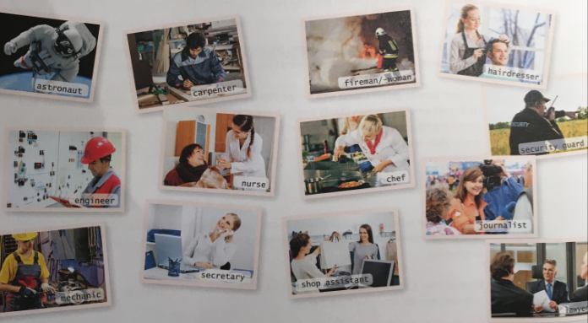
Which job did you choose? (at least 1 sentence)
What activities will you do when you work in this job? (at least 4 sentences)
Why do you want you to be a/an…? (at least 3 sentences)
What job requirements are needed for this job? (at least 4 adjectives)
Why are you the best choice for this job? (at least 1 sentence)

Evaluation grid
 | sometimes | mostly | always
Content: The student answers the questions correctly. The answers are of an appropriate length for the task
Language: The student uses the tenses correctly, especially the future tense (will). | 1 | 2 | 3
Style: The student answers the questions in correct sentences (not only keywords). The students intonation and pronunciation is  Appropriate. | 1 | 2 | 3

C: Talk about your future.
Prepare a talk about your future. What will you do…
Lifestyle
Lifestyle
House
Learning
Partner
Hobby
Friends
Family
Job
Travel
Next year
Next 5 years
Next 20 years

Use the future tense correctly.

Evaluation grid
 | sometimes | mostly | always
Content: The student talks in detail about all the given topics at least once. | 1 | 2 | 3
Language: The student uses the future tense correctly and uses expressions like ‘I think…, Probably…, Perhaps…, It could be that…’ | 1 | 2 | 3
Style: The student uses a good range of vocabulary, has a certain variety in sentence structure and the pronunciation is clear. | 1 | 2 | 3

