Vocabulary training
A: Name the job.

1. A person who cooks a meal is a …? ____________________________
2. A person who builts tunnels is an …? ____________________________
3. A person who makes furniture is a …? ____________________________
4. A person who repairs cars is a …? ____________________________
5. A person who cuts your hair is a …? ____________________________
6. A person who cares for people in a hospital is a …? ____________________________

Solution:
1. chef, 2. engineer, 3. carpenter, 4. mechanic, 5. hairdresser, 6. nurse

B: First translate the word, then write a good sentence with each of them.

1. atmen 4. bieten, bereitstellen
2. Werkzeug 5. reparieren
3. pünktlich 6. geeignet für

1. ________________________________________________________________________________
2. ________________________________________________________________________________
3. ________________________________________________________________________________
4. ________________________________________________________________________________
5. ________________________________________________________________________________
6. ________________________________________________________________________________

Solution:

1. breathe
2. tool
3. punctual
4. provide
5. repair
6. suited to

C: Find the correct adjecitve: (Für Niveau E, viele Adjektive sind nicht in dieser Unit drin, sondern sollten die S von früher kennen)
- When you are thirsty you order a _____________ drink at the restaurant.
- If you do a lot of sport you are very ____________.
- If you never get sick you are a _______________ person.
- In school you have to be _____________ to your teachers, than they will be ____________ to you.
- A guy who earns a lot of money spends more than 50 percent for charity. He is very ___________.
- As a carpenter you must be __________in ___________________ .
- If you want to work with tourists you have to be ________________ in ____________________.
- Mel Gibson had to be very _________________ in his movie against the Brits.
- In a relationship you must be very __________________. Your partner might have a total different perspective.
- If you want to invite some people your house should be very ______________.

D : Write down your own explanations for the following adjectives: (Für Niveau E, viele Adjektive sind nicht in dieser Unit drin, sondern sollten die S von früher kennen)
bright: ____________________________________________________________________________
lazy: ______________________________________________________________________________
honest:____________________________________________________________________________
creative:___________________________________________________________________________
ambitious:__________________________________________________________________________
punctual:___________________________________________________________________________
competent:_________________________________________________________________________
reliable:____________________________________________________________________________

E :Do the crossword puzzle! (G und E)
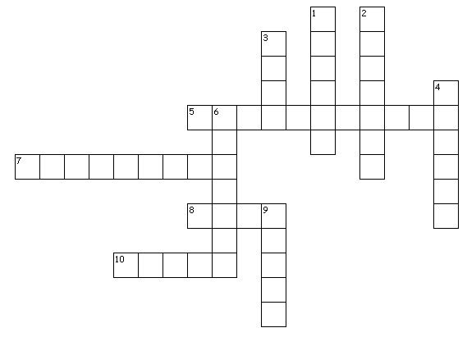
Presentin a job – austronaut
Across Down
5. Bewerbung 1. auswählen
7. Behälter 2. atmen
8. Verlust 3. Werkzeug
10. hier: Weltraum 4. unfähig, ausserstande
6. Ziel, Zweck
9. Arbeitsschicht

F: Do the crossword puzzle! (G und E)
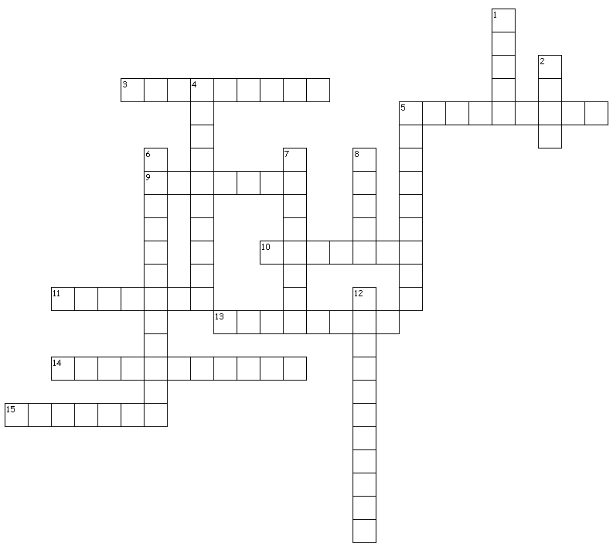

Job variety, Project Task
Across Down
3. Sekretärin 1. Krankenpfleger
5. kompetent, fähig 2. Koch
9. produzieren 4. vernünftig
10. geduldig 5. Schreiner
11. beinhalten 6. sich spezialisieren auf
13. pünktlich 7. Mechaniker
14. kooperativ 8. mutig
15. Feuerwehrmann 12. Coiffeur

G: Translation (Eher für E, G geht zum Teil Voci)

1. 1969 landeten die ersten Astronauten auf dem Mond.
________________________________________________________________________________
2. Es gibt / hat viele Arbeitsplätze / Stellen für Sekretärinnen.
________________________________________________________________________________
3. Eine Sekretärin muss fähig, zuverlässig und geduldig sein.
________________________________________________________________________________
4. Der Feuerwehrmann ist sehr mutig, aber nicht so sportlich.
________________________________________________________________________________
5. Ein Raumanzug macht uns nicht attraktiv und schlank.
________________________________________________________________________________
6. Der Arbeitgeber braucht eure Unterstützung.
________________________________________________________________________________
7. Im Weltraum gibt / hat es keine Schwerkraft.
________________________________________________________________________________
8. Du musst alles befestigen, sonst (otherwise) fliegt es herum.
________________________________________________________________________________

Solution:
1. In 1969 the first astronauts landed on the moon.
2. There are many / a lot of jobs for secretaries.
3. A secretary has to be competent, reliable and patient.
4. The fireman is very brave but not so athletic.
5. A spacesuit doesn’t make us attractive and slim.
6. The employer needs your support.
7. In space there is no gravity. / There is no gravity in space.
8. You have to attach everything, otherwise it floats around.

