Sample test exercises: reading

Source: http://www.eschooltoday.com (Only text, Questions are „new“)

The problem of Overfishing

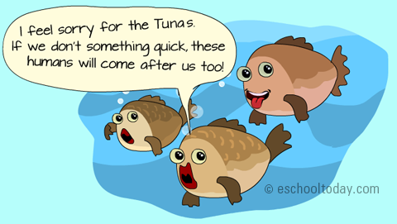
We all love to eat fish, don’t we? It is the best source of protein and very healthy food in many ways. We also know where fish comes from—our oceans.
Many decades ago, our oceans were full of fishes but unfortunately, this is not the case today.
Our world today faces many complex issues ranging from pollution, climate change, wars, food crises, waste, over-population… and of course over-fishing.
These are all problems we have created for ourselves, often as a result of our selfish activities.
Overfishing particularly is one issue that is often underrated. This is because we do not hear about it often, and we also do not live in water so we do not care what happens there. Also, we mostly get as much fish as we would like from the market so what is the big deal?

- Why is fish such a good food for us? Give two reasons.
________________________________________________________________________________
________________________________________________________________________________

- Why is the problem of “Overfishing” often underrated? Give three reasons.
________________________________________________________________________________
________________________________________________________________________________
________________________________________________________________________________

What is overfishing?
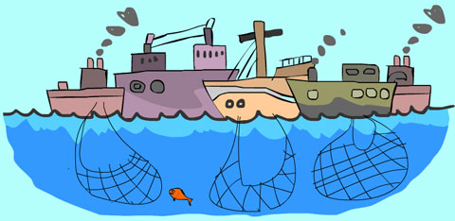
Overfishing is simply a situation where humans catch too much fish from the oceans (and also water bodies) in such massive quantities and fast pace than nature can naturally replenish. In other words, it is when we take out more fish than the fish can naturally replace. This leads to a degradation of our oceans, making it a non-sustainable use of the world’s oceans.
In recent time, technology, better equipment and humans need for more money have made it easier for fishes to be caught with less effort. Unfortunately, as we catch more and more fish, they run out and both commercial and non-commercial fishermen have to go deeper into sea to get fish. This is particularly scary for the Bluefin Tuna species.
The population of Bluefin Tuna has reached a critically low level, with all scientific advice agreeing on the need for a drastic reduction of fishing levels and a fishing closure during the spawning season to allow the stock to recover. Failure to act will push Bluefin tuna fishery to extinction says IUCN, 26 November 2008 | News story.
Scientists and researchers report that fish populations have fallen to a level that can be called a crisis. What makes matters worse is that, other marine animals are destroyed in the process.
The FAO has pointed out that about 25 percent of the world’s captured fish end up thrown overboard because they are caught unintentionally, are illegal market species, or are of inferior quality and size. Many of the fish caught this way include endangered and over exploited species, 95 percent of which are eventually thrown away. www.dujs.dartmouth.edu

- Line 1-12: What’s “Overfishing”. Write down a definition!
________________________________________________________________________________________________________________________________________________________________

- Line 14-17: Give three reasons why it has become easier to catch bigger amounts of fish.
________________________________________________________________________________________________________________________________________________________________________________________________________________________________________________

- Line 19-22: What do you know about the Bluefin Tuna? Write down at least two facts.
________________________________________________________________________________________________________________________________________________________________

- Line 24: Translate this sentence: “… that fish populations have fallen to a level that can be called a crisis.”
________________________________________________________________________________________________________________________________________________________________

- Line 27-30: What happens with 25 percent of the caught fish?
________________________________________________________________________________________________________________________________________________________________________________________________________________________________________________________________________________________________________________________________

