Sample test exercises: reading
A : Read the following game rules. Which game is explained?
Source: Most texts and pictures from: http://www.jaqueslondon.co.uk

Outdoor games:
This game traces its history back many hundreds of years in England and has been played for over 100 years. The game is very simple to play and can help children with basic addition and mathematics, as they will have to add up their points. Each point on the base has a separate value, according to the difficulty of the throw. Our machine crafted game is made from beautiful solid wood with heavy duty natural rope rings.
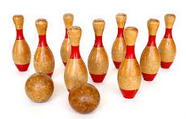 | 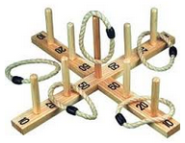 | 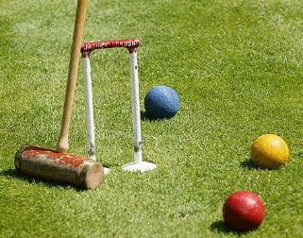
⃝ Skittles | ⃝ Quoits | ⃝ Croquet

Pub games:
It is a great game for all the family to play, which has been a popular pastime for centuries. It was so popular in medieval England that large amounts of money could be wagered on the game, and the board had to be kept in a room at the back of pubs to prevent untrustworthy patrons from playing and causing brawls that would be bad for business. Even King Henry the VIII of England played, and records show that he had to pay out substantial sums to members of his court who beat him. The game is played with five coins, which are shoved up the board, which is scored with horizontal lines.
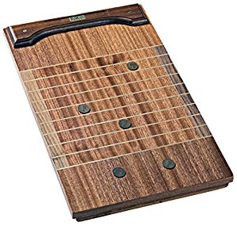 | 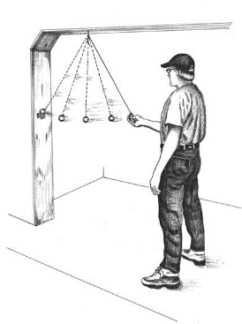 | 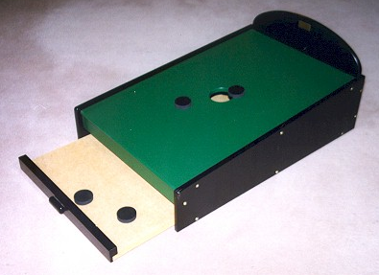
⃝ Shove Ha’penny | ⃝ Ringing the bull | ⃝ Toad in a hole

Indoor games:
This game has been a popular traditional game throughout the world for over 100 years and that popularity continues to grow! It holds a particular importance for American submariners as their 'official' pastime - the wardroom of the oldest submarine in the fleet carries Dick O'Kane's personal game on board, and upon decommissioning it is transferred to the next oldest boat. The game can be played by anywhere between 2 and 4 players. To play this game you need a set of 52 playing cards and a board to score -technically the board is the scoring device. The game is divided into two rounds: one playing round and the second a scoring round. The winner of the game is the first person to reach 121 points on the board.
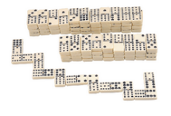 | 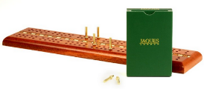 | 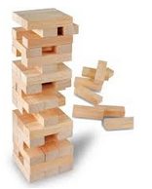
⃝ Domino | ⃝ Cribbage | ⃝ Tumble tower

B: Answer the questions
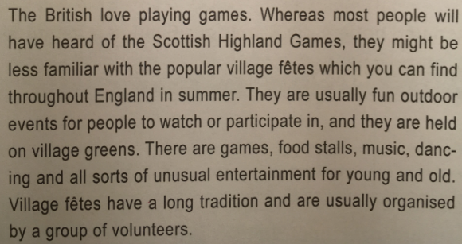
What is a village fête? Explain in your own words.
____________________________________________________________________________________________________________________________________________________________________

Where do they take place?
____________________________________________________________________________________________________________________________________________________________________

Who organises village fêtes?
____________________________________________________________________________________________________________________________________________________________________

What can you do at a village fête?
____________________________________________________________________________________________________________________________________________________________________
____________________________________________________________________________________________________________________________________________________________________

Why are less people familiar with the village fêtes than with the Highland Games?
____________________________________________________________________________________________________________________________________________________________________
____________________________________________________________________________________________________________________________________________________________________

Do we have things like this in Switzerland? Explain.
____________________________________________________________________________________________________________________________________________________________________
____________________________________________________________________________________________________________________________________________________________________

