Sample test exercises: reading

A: Read these music critics. Are they good or bad ? Give them one, two or three stars.
: very good : neither good, nor bad :awful
1.
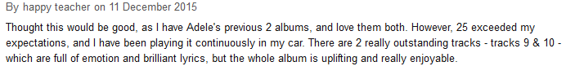

2.
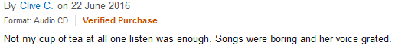

3.
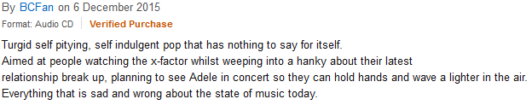

4.

5.

6.

Solution :
1. 3 stars 2. 1 star 3. 1 star 4. 2 stars 5. 3 stars 6. 2 stars

