This, that, these, those

A: Practise this, that, these, those by making sentences
(Source: For you, Verlag der Sekundarlehrerkonferenz des Kantons Zürich)
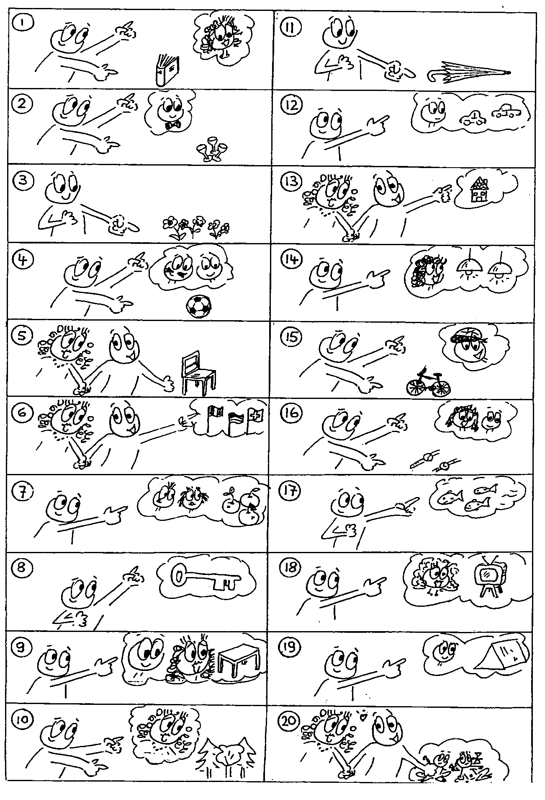

B: Write the sentences next to the correct picture.
(Source: Non Stop English, Lehrmittelverlag des Kanton Zürich)
That is her book. | These are our books. | Those are her books.
That is his book. | This is my book. | Those are their books.
That is their book. | This is our book.
These are my books. | Those are his books.

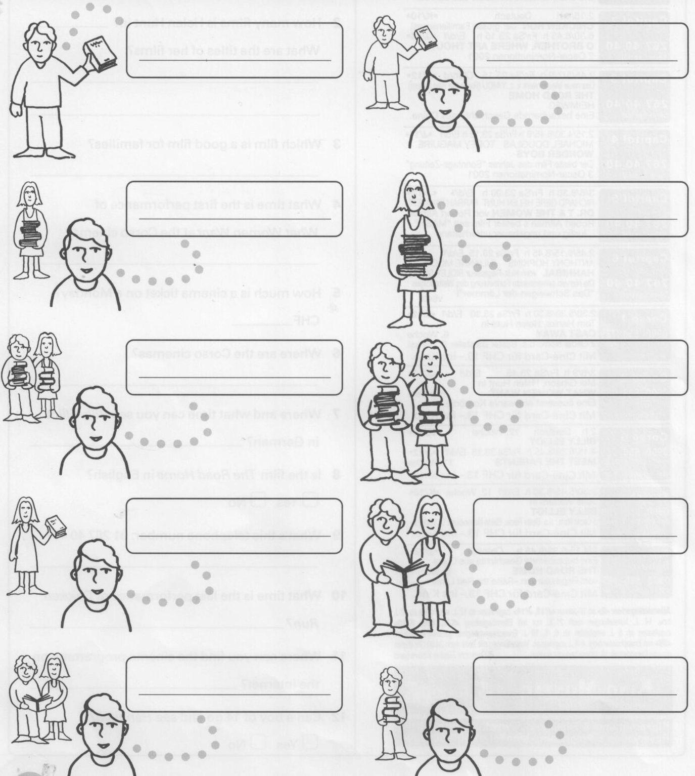

C : Write the correct word in the gap. (this, that, these, those)
- Look ________ are my grandparents, and ___________ people over there are my friend's grandparents.
- ______ building over there is the Chrysler Building.
- _______ was a great evening, but now it’s time to go home.
- ________ bricks over there are for your chimney.
- On the phone:
Sue: Hello, Jane. ________ is Sue.
Jane : Oh, hi Sue. How are you ?
Sue: You’re a friend of John’s, aren’t you ?
Jane: Yes, ______ is right.
Sue: Luke plays the piano very well.
Jane : Does he ? I didn’t know ________.

D: Onlineübungen (fürs Selbststudium der Schüler) unter:
http://www.englisch-hilfen.de/en/exercises/various/this_that.htm

E: Write the word to fill the gaps. Use this / that / these / those.

- ________________ are my tights! Yours are ___________ over there!

- Do you like _______________ apples here? No thanks, I prefer _____________ red ones over there.

- I hate ___________________ horror films on TV.

- Look, ___________ aeroplane is very high up in the sky.

- I like __________________ photo here very much.

- Do you see ____________________ tree on the hill? It’s a hundred years old.

- ___________ whale here is amazing! Have you seen ______________ baleen whales over there?

F: Write the word to fill the gaps. Use this / that / these / those.

1. I’m really busy _______________ morning.

2. _______________ cake you made last week was delicious.

3. Let me introduce you. Sue, _______________ is Tom.

4. I’m going to take back _______________ shoes I bought last week.

5. Are you going to watch _______________ DVD with us?

6. First you need to chop up _______________ tomatoes over there.

7. Hello, _______________ is Nick speaking.

- Yes, _______________’s right. I completely agree with you

