Sample test exercises: reading

A: Read this Blog entry and answer the questions below.
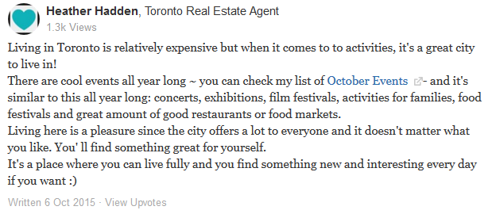

1. Heather Hadden mentions one disadvantage to live in Toronto. Which one?
_____________________________________________________________

2. Why is Toronto a great city?
⃝ it’s expensive ⃝ you can do a lot of activities ⃝ Toronto has cool temperatures

3. Write down at least 3 advantages (Vorteile) to live in Toronto.
______________________________________________________________________________________________________________________________________________________________________________________________________________________________________________________

4. There are a lot of events all year long. Match the events with their explainations. (eher für E)
concerts |  | You can buy there different groceries often provided by local producers.
exhibitions |  | Over 100 stands and trucks selling delicacies from all over the world and you can eat outside on the streets.
food festivals |  | You have the chance to see special items that are presented in museums or galleries.
food markets |  | See many different movies in one or more cinemas or screening venues.
film festivals |  | Listen to a band that plays live music in front of an audience.

4. Are these events just in October or can you find such events in every month of the year ?
____________________________________________________________

