Vocabulary training
A: Use the following words in a sentence! („fall in love“ und „inhabitant“ bei G nicht im Voci)
feel at home _______________________________________________________________
advantage __________________________________________________________________
flag ________________________________________________________________________
inhabitant __________________________________________________________________
education ___________________________________________________________________
fall in love ___________________________________________________________________

Solution:
feel at home sich zu Hause fühlen
advantage Vorteil
flag Flagge
inhabitant Einwohner, Einwohnerin
education Bildung, Ausbildung
fall in love sich verlieben

B: Rearange the words to sentences! (Satz 1 für G nicht geeignet, da nicht im Voci)
1. in common / a list/ you have/ of the things/ make/.
__________________________________________________________________________
2. friendly/ your neighbours/ integration / are/ is/ easy/ if/. ___________________________________________________________________________
3. something new/ a great opportunity/ this is/ to learn/. ___________________________________________________________________________
4. married / they/ a/ got/ ago/ year/.
__________________________________________________________________________
5. education/ I /is/ that/ think/important/ very. ___________________________________________________________________________
6. pictures/ connect/ you/ the/ can/ to/ words/ the/? ___________________________________________________________________________

Solution:
Make a list of the things you have in common.
Integration is easy if your neighbours are friendly
This is a great opportunity to learn something new.
They got married last year.
I think that education is very important.
Can you connect the words to the pictures?

C: Seperate the words with a line! (Version E)
communityyearhomedisadvantageeducationdivideidentityoriginnativelanguagesupporttopicconnectwelcomeevaluatestrengthvarietyinhabitanttourguidegenerationreactsocietyfacility
Translate the above words!
__________________________________________________________________________________________________________________________________________________________________________________________________________________________________________________________________________________________________________________________________________________________________________________________________________________________

Solution Version E : community/year/home/disadvantage/education/divide/identity/origin/native/language/support/topic/connect/welcome/evaluate/strength/variety/inhabitant/tour/guide/generation/react/society/facility/

Gemeinde/Jahr/Heimat/Nachteil/Bildung/aufteilen/Identität/Herkunft/Muttersprache/unterstützen/Thema/verbinden/willkommen/bewerten/Kraft, Stärke/Vielfalt/ Bewohner/ Reiseleiter,-in/Generation/reagieren/Gesellschaft/Einrichtung, Anlage

D: Seperate the words with a line! (Version G)
communityhomedisadvantageeducationidentityoriginnativelanguagesupporttopicconnectwelcomestrengthgenerationreactsociety
Translate the above words!
__________________________________________________________________________________________________________________________________________________________________________________________________________________________________________________________________________________________________________________________________________________________________________________________________________________________

Solution Version G :
community/home/disadvantage/education/identity/origin/native/language/support/topic/connect/welcome/strength/generation/react/society

Gemeinde/Heimat/Nachteil/Bildung/Identität/Herkunft/Muttersprache/unterstützen/Thema/verbinden/willkommen/Kraft, Stärke/ Generation/reagieren/Gesellschaft

E: Do the crossword puzzle (Parts: “Introduction” and “multicultural neighbourhoods”)
(“Nachteil”, “Reiseleiter” und “Vielfalt” im Voci von G nicht drin)
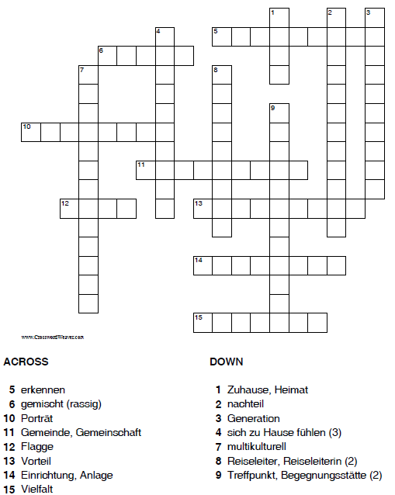

Solution:
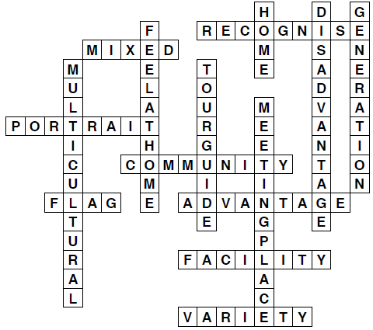

F: Do the crossword puzzle (Part: “Diversity is our strength”)
(“Wohltätigkeitsorganisation”, “aufteilen”, “sich verlieben” und “Absicht” im Voci von G nicht drin)
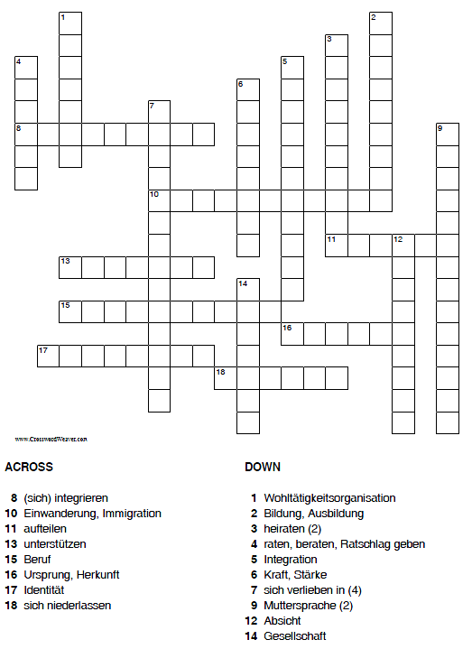

Solution:
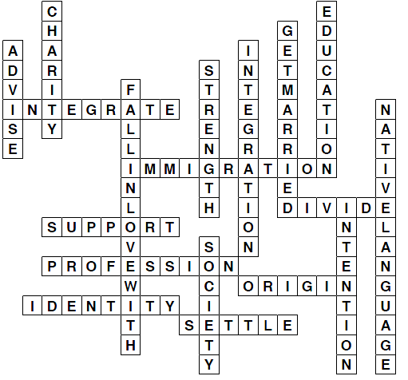

G: Do the crossword puzzle (Parts: “Let’s mix” and “Mixie us”)
(“gemeinsam”, “Einwohner”, “Spezialität” und “bewerten” im Voci von G nicht drin)
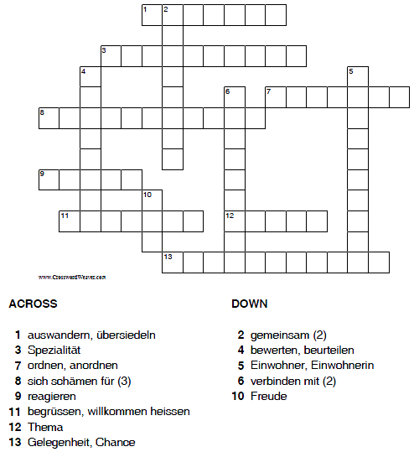

Solution:
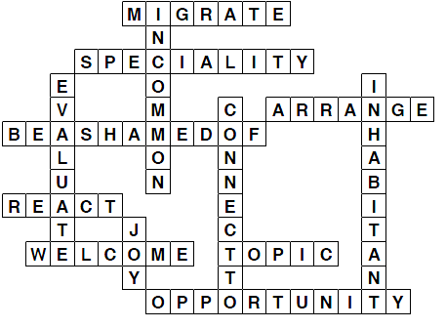

F: Do the crossword puzzle (Niveau G)
 |  |  |  |  |  |  |  |  |  |  |  |  |  | ₁ |  |  |  |  | ₂
 |  |  |  |  |  |  |  |  |  |  |  |  |  | ₃
 |  |  |  |  |  |  |  |  |  |  |  |  | ₄ |  |  |  |  | ₅
 |  |  |  |  |  |  |  |  |  |  |  |  |  | ₆
 |  |  |  |  |  |  |  |  |  |  | ₇
 |  |  |  |  |  |  |  |  |  |  |  |  | ₈
 |  |  |  |  |  |  |  | ₉ |  | ₁₀ |  | ₁₁ |  |  |  |  |  | ₁₂
 |  |  |  | ₁₃
 |  |  |  |  |  |  |  |  |  |  |  |  |  |  |  |  |  |  |  |  |  | ₁₄
 |  |  |  |  |  |  |  |  |  |  |  |  |  |  |  | ₁₅ |  |  |  | ₁₆
 |  |  |  |  |  |  |  | ₁₇
 |  |  | ₁₈
 |  |  |  |  |  |  |  |  |  | ₁₉ |  | ₂₀
 |  |  |  |  |  |  |  |  |  | ₂
 |  |  |  |  |  | ₂₂ |  |  |  |  |  |  |  |  |  |  |  | ₂₃
 |  |  |  |  |  | ₂₄ |  |  |  |  |  |  |  | ₂₅
₂₆
 |  | ₂₇
 | ₂₈
 |  |  |  |  | ₂₉

Across: 1. Beruf 4. Freude 5. Gesellschaft
6. auswandern, übersiedeln 8. (sich) integrieren 10. reagieren
13. gemischt(rassig) 15. erkennen 17. Kraft, Stärke
18. sich niederlassen 20. ordnen, anordnen 21. Identität 24. multikulturell 26. Porträt 27. Gelegenheit
28. Bildung, Ausbildung 29. Integration

Down: 2. unterstützen 3. Gemeinde, Gemeinschaft 7. Zuhause, Heimat
9. raten, beraten, Ratschlag geben 11. Vorteil
12. begrüssen, willkommen heissen 14. Nachteil 16. Generation
19. Ursprung, Herkunft 22. Einwanderung 23. Flagge
25. Thema

Solution:
 |  |  |  |  |  |  |  |  |  |  |  |  |  |  | ₁ |  |  |  |  | ₂
 |  |  |  |  |  |  |  |  |  |  |  |  |  |  | ₃
 |  |  |  |  |  |  |  |  |  |  |  |  |  | ₄ |  |  |  |  | ₅
 |  |  |  |  |  |  |  |  |  |  |  |  |  |  | ₆
 |  |  |  |  |  |  |  |  |  |  |  | ₇
 |  |  |  |  |  |  |  |  |  |  |  |  |  | ₈
 |  |  |  |  |  |  |  |  | ₉ |  | ₁₀ |  | ₁₁ |  |  |  |  |  | ₁₂
 |  |  |  |  | ₁₃
 |  |  |  |  |  |  |  |  |  |  |  |  |  |  |  |  |  |  |  |  |  |  | ₁₄
 |  |  |  |  |  |  |  |  |  |  |  |  |  |  |  |  | ₁₅ |  |  |  | ₁₆
 |  |  |  |  |  |  |  |  | ₁₇
 |  |  |  | ₁₈
 |  |  |  |  |  |  |  |  |  |  | ₁₉ |  | ₂₀
 |  |  |  |  |  |  |  |  |  |  | ₂₁
 |  |  |  |  |  |  | ₂₂ |  |  |  |  |  |  |  |  |  |  |  | ₂₃
 |  |  |  |  |  |  | ₂₄ |  |  |  |  |  |  |  | ₂₅
₂₆
 |  | ₂₇
 | ₂₈
 |  |  |  |  |  | ₂₉

G: Complete the sentences, use your «my resources». (Niveau G)
1. Do you ________ ___ ______ in Switzerland?
2. Can you ____________ the words ____ the pictures?
3. Don’t _____ _______________ ____ your accent – your English is good.
4. His _____________ ________________ is Romansh.
5. They ______ ________________ a year ago.
6. This youth hostel is a _______________ ______ for students.

