Sample test exercises: reading

Read the two texts carefully. Mark important facts and do the following exercises:
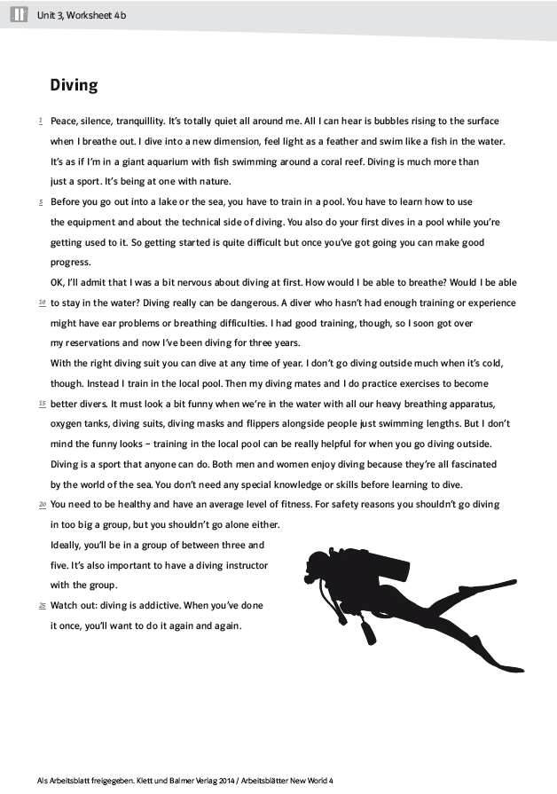
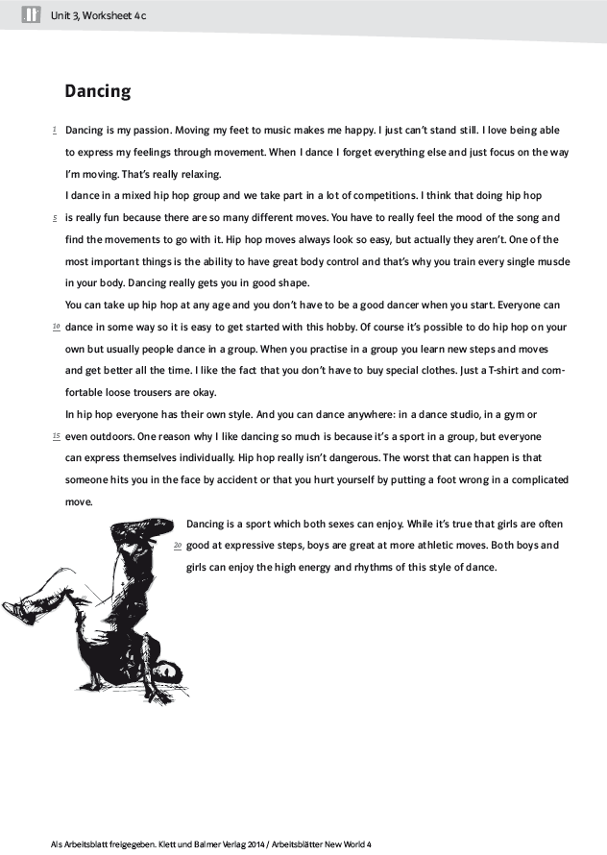

A : True (T) or false (F)? Answer according to the text:
Dancing (Caroline)
 | T | F
Girls are usually better at hip hop dancing.
Hip hop moves are very easy.
Dancing keeps you fit.
It is important to control your body.
Hip hop is a highly dangerous sport with complicated injuries.
In a hip hop group, all the dancers have the same style.

Diving (Laura)
 | T | F
Learning diving is easy.
Diving on your own is not a good thing to do.
Without training, diving can cause serious health problems.
Laura was very relaxed before her first dive.
Laura goes diving do keep fit.
Diving in winter is possible.

B: Find the words in the text „Dancing“:

e.g.: both sexes (l.19) = men and women

1. ...................................... = strong emotion, love
2. ...................................... = learn
3. ...................................... = a match, an event

C: Find the words in the text „Diving“:

e.g.: addictive (l.25) = you depend on it, you can’t stop it

1. ...................................... = very big
2. ...................................... = friends
3. ...................................... = teacher, guide

D: Verbs and nouns: Complete the table:

verb | noun
to move
 | expression
 | training

E: Adjectives and nouns: Complete the table:

adjective | noun
safe
 | health
 | technology

F : Answer these questions. Try to use your own words.

- What does Caroline like about dancing?
.........................................................................................................................................
.........................................................................................................................................
.........................................................................................................................................
- What does Laura like about diving?
.........................................................................................................................................
.........................................................................................................................................
.........................................................................................................................................

- Which of these two sports attracts you more? Why?
.........................................................................................................................................
.........................................................................................................................................
.........................................................................................................................................

