Vocabulary training
A : Make sentences!
aim/climb/mountain
___________________________________________________________________________
helicopter/rescue/mountain biker ___________________________________________________________________________
injure/ shoulder/carry on running ___________________________________________________________________________

Solution :
aim/climb/mountain______It is his aim to climb that mountain. _____________________
helicopter/rescue/mountain biker The helicopter rescued the injured mountain biker.______
injure/ shoulder/carry on running _____He carried on running with an injured shoulder. __

B : Unscramble the words!
soppturer ____________________________ capmilon __________________________
mavtitoe _____________________________ segusgset __________________________

Solution:
soppturer _______supporter capmilon ______complain_________
mavtitoe ______motivate _____________ segusgset ______suggest________

C: Use the following words in sentences! Use different activities.
1. adore ...ing _________________________________________________________________
2. I can’t stand ...ing ____________________________________________________________
3. keen on ...ing _______________________________________________________________
4. I don’t mind ..ing _____________________________________________________________
5. carry on ...ing _______________________________________________________________
6. hate ...ing __________________________________________________________________
7. I would rather(do A) than (B) ___________________________________________________
8. like .. ing ___________________________________________________________________

Solution :
1. He adores climbing trees.
2. I can’t stand playing football
3. I’m keen on riding
4. I don’t mind walking
5. He carries on shouting
6. They hate doing homework
7. I would rather eat an ice cream than clean my room.
8. She likes walking the dog

D: Connect the words that belong together!
lazy motivieren überfliegen/durchsehen motivate
suitable Entwurf draft faul skim geeignet

Solution:
lazy motivieren überfliegen/durchsehen motivate
suitable Entwurf draft faul skim geeignet

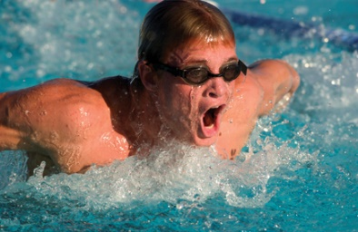
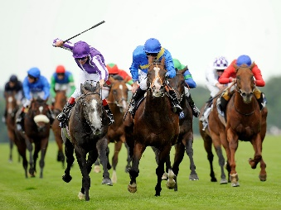
E: Sports activities: Write the name for each sport under the picture.
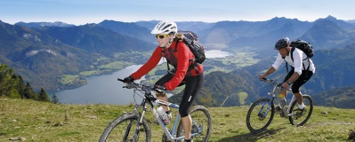
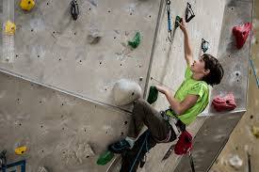
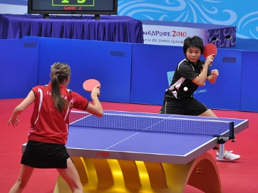
___________________ ___________________ ___________________
_________________ ______________________ ___________________

F: How many sports can you collect in these categories?

 |  | 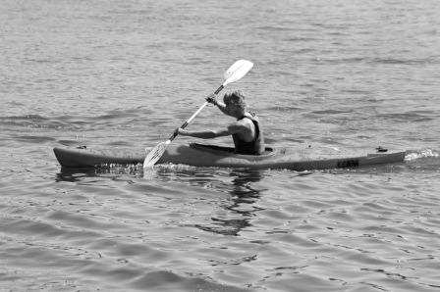 |  | 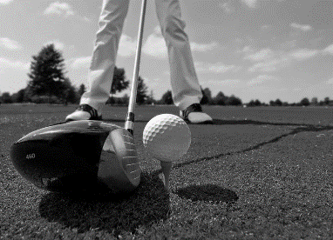
winter sports |  | water sports |  | sports with a ball
ice-skating |  | canoeing |  | golf

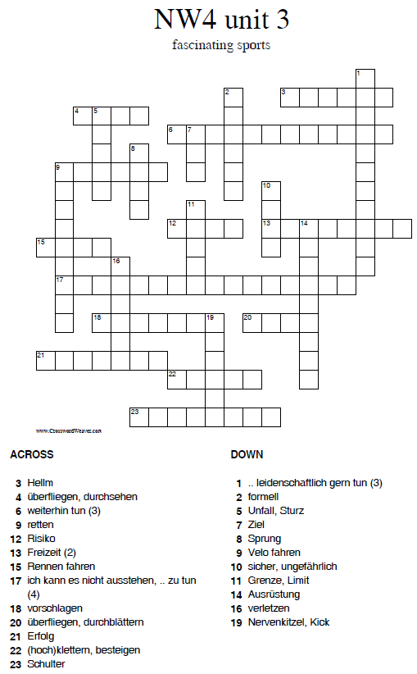

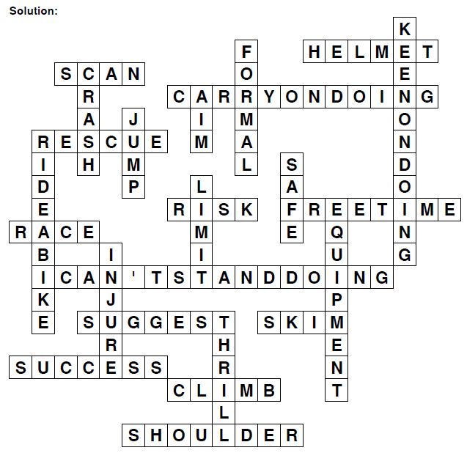

G: Use the “my resources” and complete the sentences. (Niveau G, Introduction, Fans and players)

1. If you don’t know the name of the person you write: ___________________________.
2. We learnt how to write a __________ letter.
3. She _______ _______ watching football on TV.
4. Do you really ______ ___________ tennis?
5. Don’t forget to ________ _______ _________ in a letter.
6. What do you do in your ______ ________?
7. This sport is _____________ for men and women.
8. My sister _________ __________ outdoors sports.
9. We had a really ___________ training session yesterday.
10. He ________ ___________ after a ball.
11. If you know the name of the person you write: _______________________________.
12. My team ______________ me to train hard.
13. Nobody can read our head teacher’s _______________________.
14. I’d like to _____________ a new game.
15. Canadians ___________ _______________ ice hockey.
16. He doesn’t like exercising – he’s a bit _________.

Solution

1. If you don’t know the name of the person you write: Yours faithfully.
2. We learnt how to write a formal letter.
3. She can’t stand watching football on TV.
4. Do you really like watching tennis?
5. Don’t forget to sign your name in a letter.
6. What do you do in your free time?
7. This sport is suitable for men and women.
8. My sister enjoys doing outdoors sports.
9. We had a really tough training session yesterday.
10. He hates running after a ball.
11. If you know the name of the person you write: Yours sincerely.
12. My team motivates me to train hard.
13. Nobody can read our head teacher’s signature.
14. I’d like to suggest a new game.
15. Canadians adore watching ice hockey.
16. He doesn’t like exercising – he’s a bit lazy.

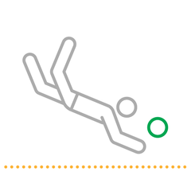
H: Do you know the name of these sports?
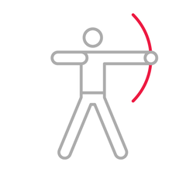

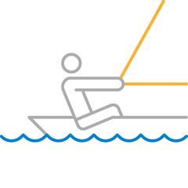

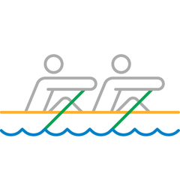
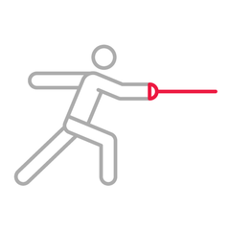

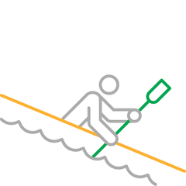
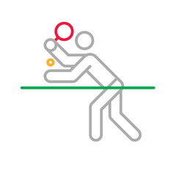

I: Do the crisscross puzzle (Niveau G: Fascinating sports and a new school sports)

 |  |  |  |  |  | ₁
 |  |  | ₂ |  |  |  |  | ₃
 | ₄
₅ |  |  |  | ₆ |  |  | ₇
 |  |  |  |  |  |  | ₈ |  |  | ₉
 |  |  |  |  |  | ₁₀
 |  |  |  | ₁₁
 |  |  |  |  |  |  |  | ₁₂
 |  |  |  |  |  |  |  |  |  | ₁₃ | ₁₄

Across: 2. durchblättern, 5. Unterschrift, 8. sicher/ ungefährlich, 11. sich beklagen,
12. Grenze, 13. Nervenkitzel

Down: 1. Sprung, 2. durchsehen, 3. Rennen fahren, 4. klettern, 6. Ziel, 7. Risiko
9. Ausrüstung, 10. verbessern, 11. Unfall/ Sturz, 14. Helm
Solution
 |  |  |  |  |  | ₁j
 |  |  |  |  |  | u
 |  |  | ₂s | k | i | m |  | ₃r
 | ₄c |  | c |  |  | p |  | a
 | l |  | a |  |  |  |  | c
₅s | i | g | n | ₆a | t | u | ₇r | e
 | m |  |  | i |  |  | i
 | b |  |  | m |  |  | ₈s | a | f | ₉e
 |  |  |  |  |  |  | k |  |  | q
 |  |  |  |  |  | ₁₀i |  |  |  | u
 |  |  |  | ₁₁c | o | m | p | l | a | i | n
 |  |  |  | r |  | p |  |  |  | p
 |  |  |  | a |  | r |  | ₁₂l | i | m | i | t
 |  |  |  | s |  | o |  |  |  | e
 |  |  |  | h |  | v |  |  |  | n
 |  |  |  |  |  | e |  |  |  | ₁₃t | ₁₄h | r | i | l | l
 |  |  |  |  |  |  |  |  |  |  | e
 |  |  |  |  |  |  |  |  |  |  | l
 |  |  |  |  |  |  |  |  |  |  | m
 |  |  |  |  |  |  |  |  |  |  | e
 |  |  |  |  |  |  |  |  |  |  | t

