Beeing in a street gang
Hier einige Hilfen, um den Einstieg in die Unit und das Unitthema einfacher zu gestalten. Zu den drei Fragen auf der Einstiegsseite gibt es je eine Idee für Hilfestellungen.
Question 1 from the book: What is a street gang? Look at the pictures for ideas.
Here you find some words that can help you to describe the pictures.
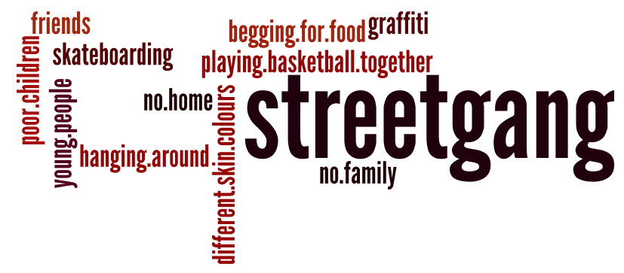
Question 2 from the book : Choose one of the street gangs in the pictures. Say what they do together.
Here you find some ideas, what they probabley do. Match these ideas tot he pictures.
- hang around together
- begging for food
- playing basketpall
- go skateboarding
- listen to music
- go to concerts
- play
- …

Question 3 from the book: What is fascinating about being part of a street gang? What is dangerous. Make a list of your ideas.
Here you find some fascinating things and some dangerous things. Cross wheather it is a benefit or a risk.
 | fascinating | dangerous
You have someone to talk about your secrets.
It’s never boring.
You do criminal things because others of your gang do.
If you need any help you can count on your street gang members.
The boss of our gang is violent.
You have to do what the boss of the gang decide.
A street gang is like a family.
Very often street gang members take drugs.

