Supper in the workhouse – Find verbs in simple past
A: All the regular and irregular verb forms are already marked in the text.
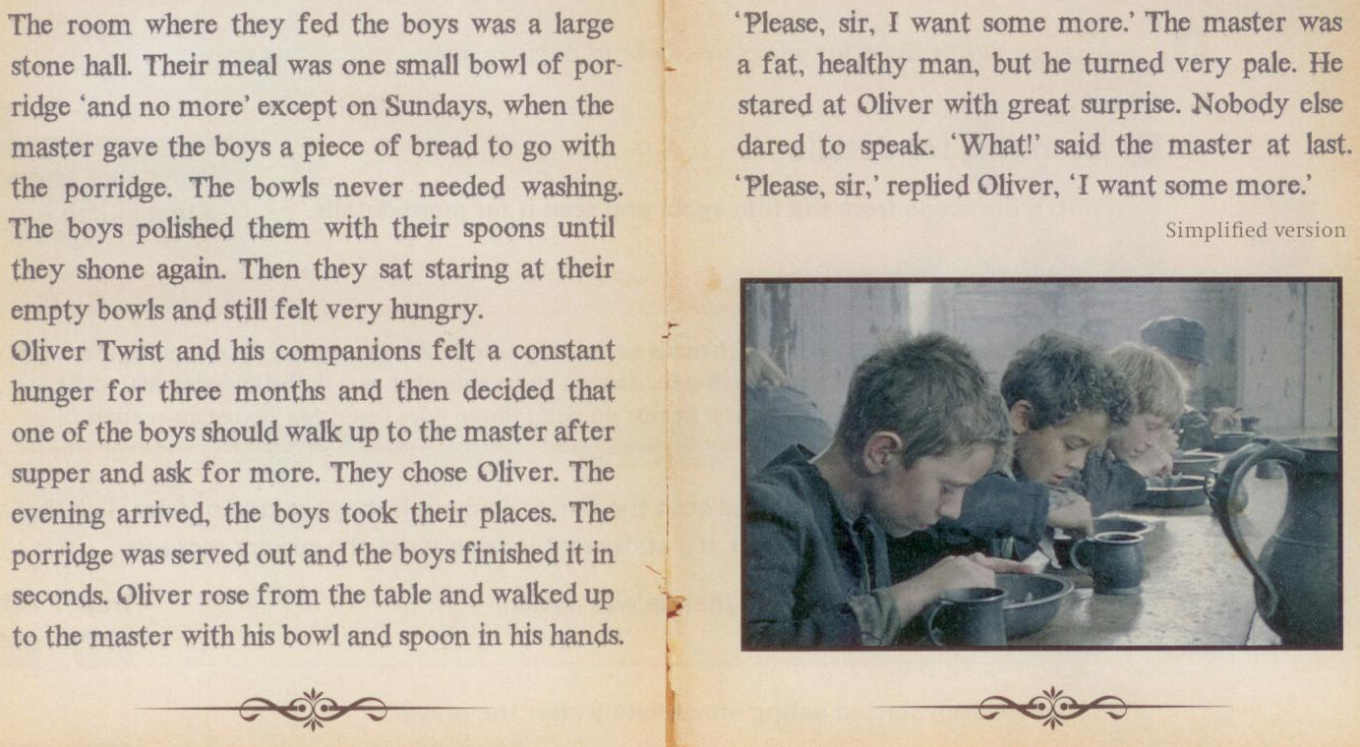
Find the regular and irregular verb forms and write them in the table on page 79 of your coursebook.

