Oliver Twist goes to London
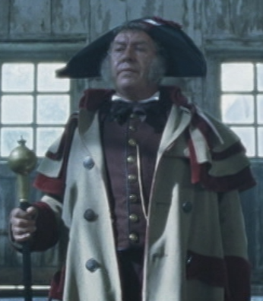
A: Read the next passage of the novel. Some keywords are translated, that may help you.
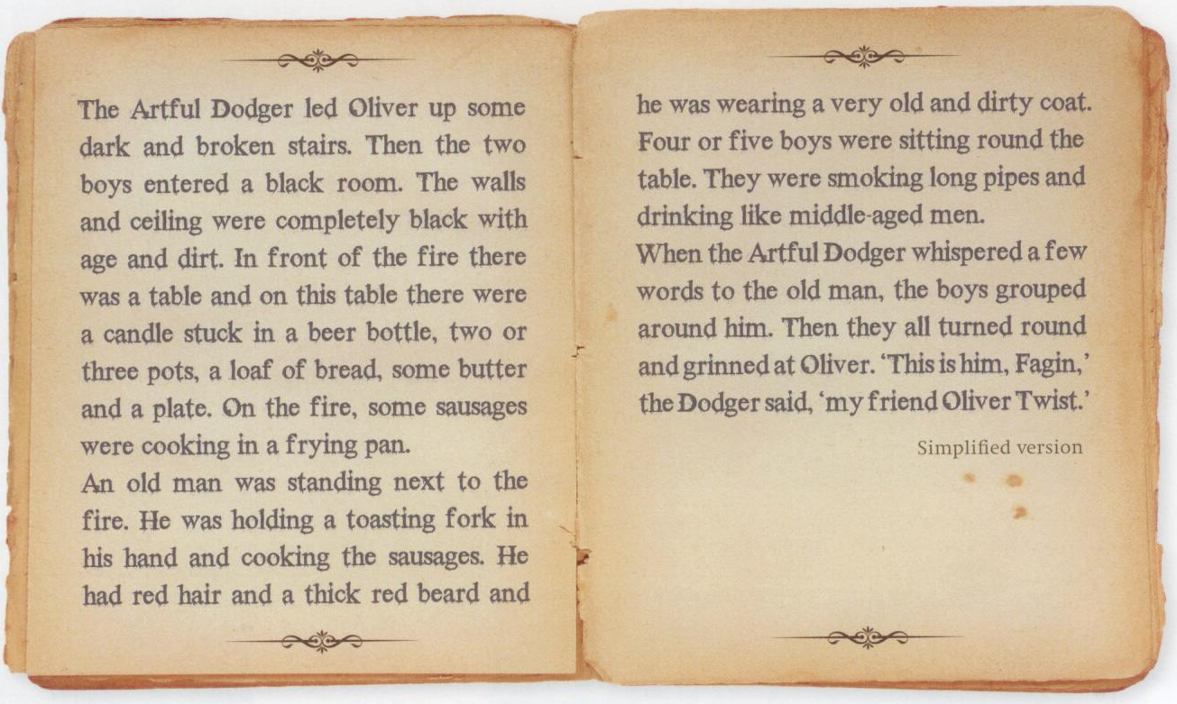
2
1
led up: hinauf führen whispered: flüsterte
stuck: gesteckt grouped: gruppierten, versammelten sich
smoking long pipes: lange Pfeiffen rauchen grinned: grinsten

B: Look at the passage nr.1 and try to draw the situation in detail.
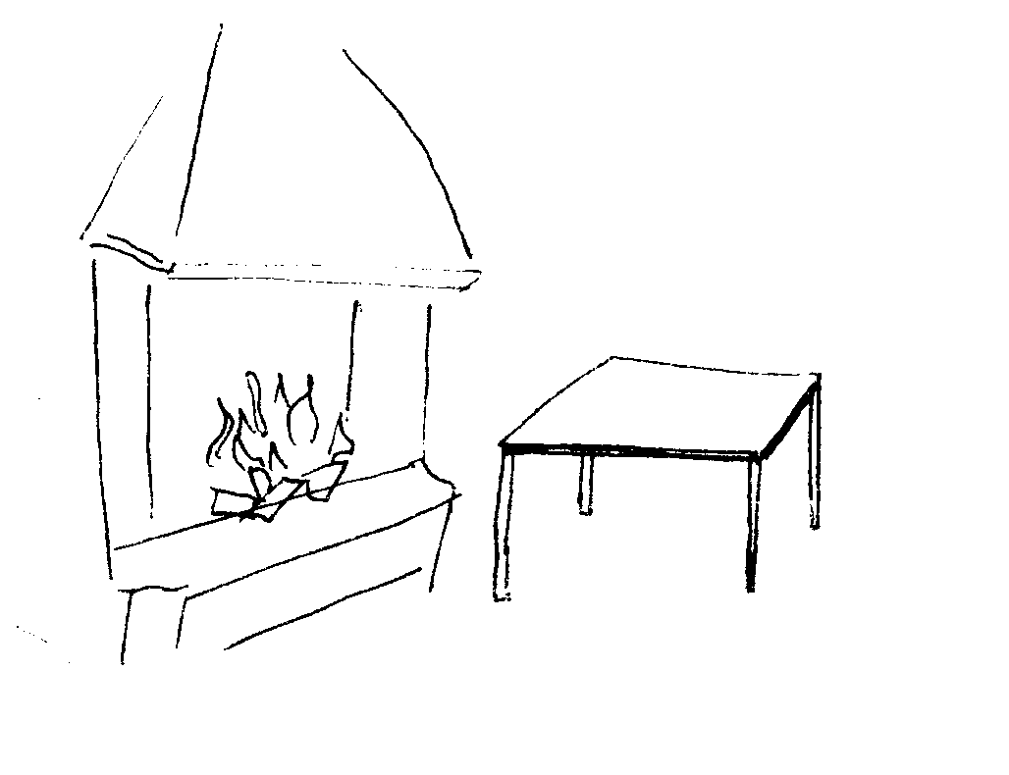
C: Look at the passage nr.2 and try to draw the old man.

