Sample test exercises : speaking
A : Prepare yourself reading this text. Underline all the words which are difficult to pronounce and learn them.

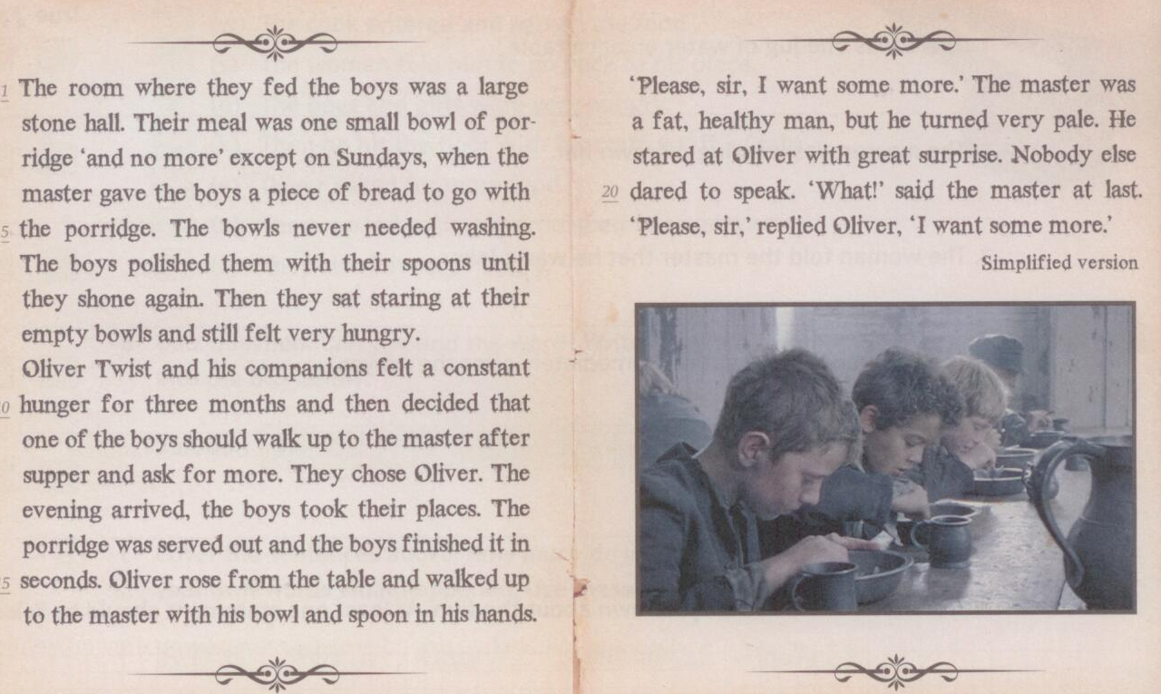

B: Read the following text aloud

Body language  Is the body language expressive and active or boring and dull ? | ⃝ 1  ⃝ 2
Intonation  Is the intonation interesting and lively or monotnous ? Is it varied and thrilling ? | ⃝ 1  ⃝ 2  ⃝ 3  ⃝ 4
Speed  Is the speed too fast or too slow ? Or is it just right? | ⃝ 1  ⃝ 2  ⃝ 3

