Sample test exercises : writing
Here you find a comic stripe of Oliver Twist. He went to Mr Bumble’s house. Oliver was very hungry and so another boy recommended him to ask for more food.
A: Read the comic and write what these persons say.
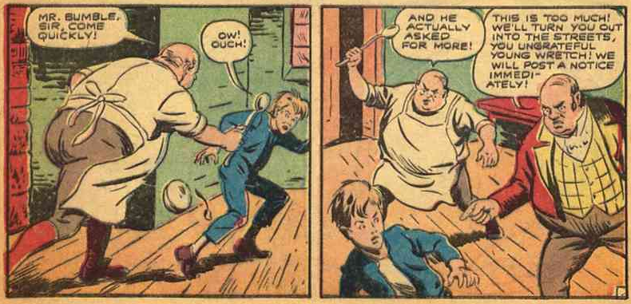
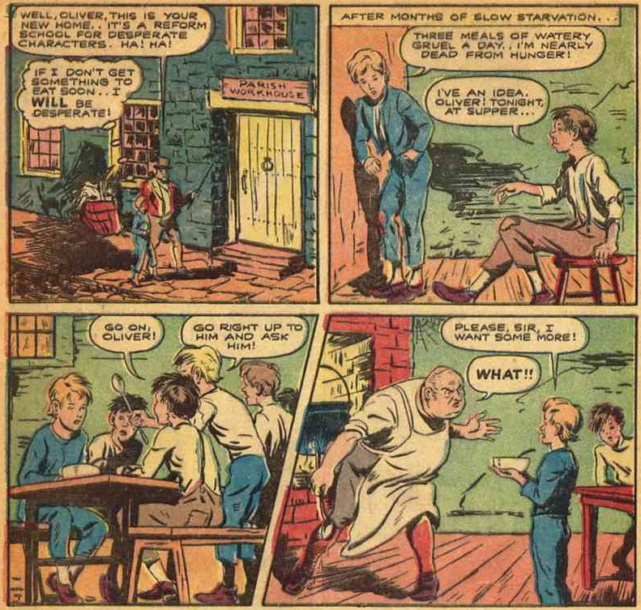
a friend
Oliver Twist

the cook

Mr. Bumble

