Sample test exercises : speaking
Introduction
We talked a lot about holidays and Australia. All nice, but now, it’s on you. It’s time to hear from your holidays!

Task
You are going to talk about one specific holiday that you have had.
- Where did you go?
- How did you travel?
- What activities did you do?
- Who did you travel with?
- When and for how long did you go?
- What was your highlight?
- What went wrong?
- Would you recommend your destination to others? Why (not)?

You don’t need to hand in a text, but you are going to record your experiences with an iPad or your mobile phone.

Date
We are going to fix the deadline for submission together in class.

Recording
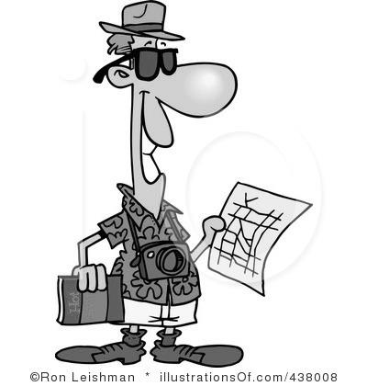
- 3-5 minutes
- Slow, clear talking
- Past simple tense
- At least 5 of the 8 questions answered

B: Work in pairs and choose the topic. One of you choose A the other one B. You have 5 minutes of preparation time (separately). Then you are going to record a role play (incl. greeting and goodbye).

At the chemists :
Student A : Customer  - you have a bad cough  - since three days  - you can’t sleep  - you would like to have medicine  - ask how much this costs | Student B : Chemist  - your customer has a bad cough  - sell him/her cough syrup and vitamin C  - this costs 23 pounds  - he/she should stay in bed

At the reception:
Student A: Backpacker  - you need some advice on what to visit in Sydney  - tell you want to see culture and beaches  - ask what you can do at the places the receptionist recommended | Student B: Receptionist  - a backpacker wants some advice on what to visit in Sydney  - recommend to see the harbour and Bondi Beach  - at the harbour you can see the Opera House. At Bondi beach you can do nice costal walks or have a surfing lesson

