**Vocabulary training**

**A: Translate and find the words! (Achtung: „amüsant/unterhaltsam, Leinwand“ sind nicht im G-Voci drin)**



1. amüsant/ unterhaltsam

2. begeistert

3. Zeitschrift

4. Versprechen

5. schreien

6. Leinwand

7. scheinen

8. Verschwendung

**Circle the unused letters and find the hidden message?** _____________________________________________

**Solution:**



English is cool

**B : Use the words in a sentence! (Achtung: „dancer, acting“ sind nicht im G-Voci drin)**

dancer _________________________________________________________________

acting __________________________________________________________________

at the office _____________________________________________________________

make a date _____________________________________________________________

fix a date ________________________________________________________________

take a message ___________________________________________________________

arrange to do sth __________________________________________________________

cut off ___________________________________________________________________

**C: Translate!**

Was gibt’s? _______________________ Geh ans Telefon! _______________________

bis später _______________________ Hier spricht X _______________________

**Solution:**

Was gibt’s? What’s on? Geh ans Telefon! Answer the phone!

bis später _See you later Hier spricht X this is X speaking

**D: Do these adjectives express positive or negative feedback about a show?**

**awful excellent gripping**

**terrible stunning impressive**

|  |  |
| --- | --- |
| negative | positive |
|  |  |

**Solution :**

|  |  |
| --- | --- |
| negative | positive |
| awful  terrible | excellent  gripping  stunning  impressive |

**F: Do the crossword puzzle!**

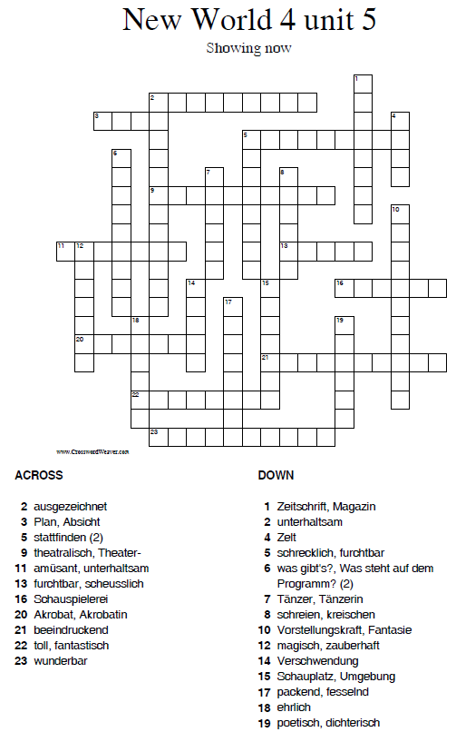

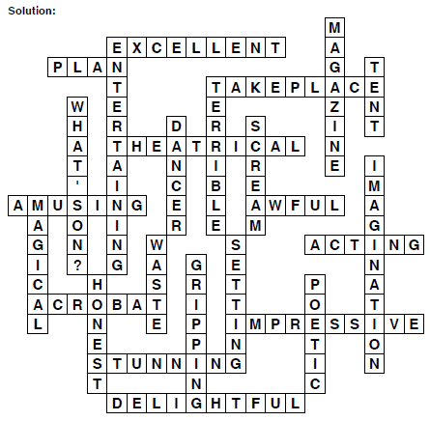

**F: Do the crossword puzzle!**

