Shortbread
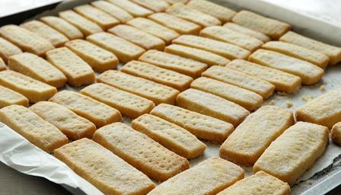
Try making these easy, buttery biscuits as homemade Christmas presents, with chocolate chips worked into the dough.

Ingredients
- 125g/4oz butter (2 parts)
- 55g/2oz caster sugar, plus extra to finish (1 part)
- 180g/6oz plain flour (3 parts)

Preparation method
- Heat the oven to 190C/375F/Gas 5.
- Beat the butter and the sugar together until smooth.
- Stir in the flour to get a smooth paste. Turn on to a work surface and gently roll out until the paste is 1cm/½in thick.
- Cut into rounds or fingers and place onto a baking tray. Sprinkle with caster sugar and chill in the fridge for 20 minutes.
- Bake in the oven for 15-20 minutes, or until pale golden-brown. Set aside to cool on a wire rack.
Add dried cranberries, chocolate drops or lemon zest to the dough.

