Grammar Practise: Present simple
A: Write down all the verbs from the text in exercise 1e, page 6. If you don't know the meaning of the verb, add the translation.
__________________________________________________________________________________________________________________________________________________________________________________________________________________________________________________________________________________________________________________________________________________________________________________________________________________________

B: Write down the verbs 'be' and 'have'
 | be |  |  | have
I | am |  | I | have
you |  |  | you
he/ she/ it |  |  | he/ she/ it
we |  |  | we
you |  |  | you
they |  |  | they

C: Write' is' or 'are' in the gap.
There ________ 6.9 millions sheep and only 5.3 million people.
Edinburgh and Glasgow ________ the two cities most tourists visit.
Edinburgh ________ quite a small city.
Scotland ________ also great for paragliding.
Ben Nevis in the Scottish Highlands ________ the hightest mountain.
These things ________ very Scottish: The bagpipes, Highland games and haggis.

D: Fill in the gaps with the correct forms of to be.

1. Steve …………. ill. He …………. in bed.
2. You …………. a good swimmer. You …………. very fit.
3. ………. it windy today ? Yes, it ……..
4. She ………. tired.
5. The weather …….. nice today. It …………. warm and sunny.
6. Emily ……… at home. Her children……… at school.

E : Write 'has' or 'have' in the gap.
Scotland ________ about 800 islands.
Scotland ________ 3 official languages.
Many Scottish people ________ red hair.
Scotland ________ a high percentage of people with red hair: 14 %.
In the USA and England only 4% of the inhabitants ________ red hair.
Glasgow and Edinburgh ________ got many interesting museums.

F: The 's'
"He/ She/ It – das 's' muss mit"
Bei he/she/it musst du dem Verb in der Gegenwart (present simple) immer ein 's' anhängen.

Look at the following sentences. Do you have to write a 's' or not?
In Scotland you walk____ on sunny beaches.
Tourists often visit____ the castle of Edinburgh.
She speak____ English, Scottish and Gaelic.
Highland cattle live____ in the Scottish Highlands.
Moira live____ in Glasgow.
John compete____ at the Highland Games this year.
Moira and John take____ a boat on one of the many lochs.

G : Write questions
Types of questions:
Question with 'be': Are you a good student? Is she a nice girl?
Questions with 'have': Have you got red hair? Has she got red hair?
Questions with 'can': Can you see the sheep?
Questions with other verbs: Do you want to travel to Scotland? Does she like shopping?

H: Choose the correct answer:
Has he got red hair? | Is | Are | Have | Has | Can | Do | Does
______ you interested in football? | Is | Are | Have | Has | Can | Do | Does
______ you like shopping ? | Is | Are | Have | Has | Can | Do | Does
______ you got Highland cattle at home? | Is | Are | Have | Has | Can | Do | Does
______ she know the Scottish Highland Games? | Is | Are | Have | Has | Can | Do | Does
______ you see Ben Nevis? | Is | Are | Have | Has | Can | Do | Does
______ they walk on sandy beaches? | Is | Are | Have | Has | Can | Do | Does
______ Edinburg a big city? | Is | Are | Have | Has | Can | Do | Does
______ you play bagpipe music? | Is | Are | Have | Has | Can | Do | Does
______ Glasgow the capital of Scotland? | Is | Are | Have | Has | Can | Do | Does
______ you sure that there is a monster called Nessie? | Is | Are | Have | Has | Can | Do | Does
______ she visit Edinburgh castle? | Is | Are | Have | Has | Can | Do | Does
______ he eat haggis? | Is | Are | Have | Has | Can | Do | Does

I : Fill in the table. (Für Niveau E)

Question : to dream (?)  Short answer (SA +/SA-) | Negative : to play
Do you dream ? Yes, I do. / No, I don’t.
 | You don’t play.

J: Work in pairs. Look at these two pictures. Find the differences.
ex. In picture A the woman wears a black blouse.

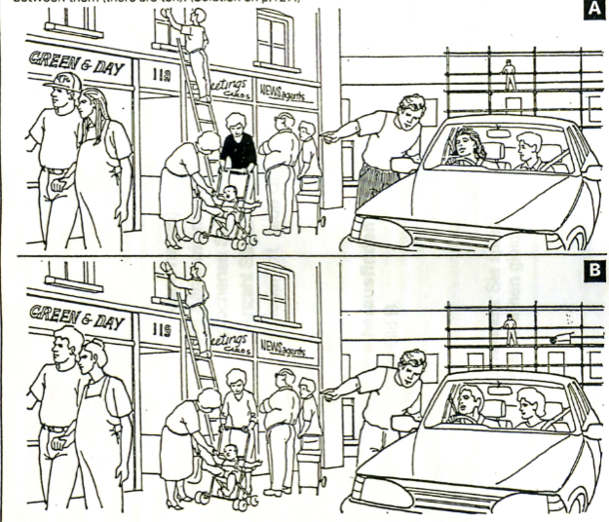

Solution: Differences between picture A and picture B
- In picture A the baby is crying.
- In picture A the mother with the pram wears a black blouse; in picture B she has a white one.
- In picture A a woman drives the car, in picture B a man is driving.
- In picture A the building in the background has four windows; in picture B it has seven windows.
- In picture A the man in the foreground next to Green & Day his wearing a cap.
- In picture A the girlfriend in the foreground has long hair; in picture B she has short hair.
- In picture A the man directing the car has striped trousers; in picture B he has white trousers.
- In picture A the number on the door is 118; in picture B it’s 119.
- In picture A the man on the ladder wears a T-shirt; in picture B he wears a long-sleeved shirt.
- In picture B there is a wheelbarrow on the scaffolding in the background.

