Grammar Practise: numbers

A: Do the crossword puzzle.
 |  |  |  |  |  |  |  |  |  |  |  |  |  | 1 |  |  |  | 2
 |  |  |  |  |  | 3 |  |  |  |  |  |  | 4 |  |  |  |  |  |  | 5
 |  |  |  |  |  |  |  |  | 6
 |  |  |  |  |  |  |  | 7
 |  |  |  |  |  | 8
 |  |  |  |  |  |  |  |  |  |  |  |  |  |  |  |  |  |  |  |  | 9
 |  |  |  |  |  |  |  | 10 |  |  |  | 11
 |  |  |  |  |  |  |  |  |  |  |  |  |  |  |  | 12
 |  |  |  |  |  |  |  |  |  |  | 13
 |  |  |  | 14 |  |  |  |  |  |  | 15
 |  |  | 16 |  |  |  |  |  | 17 |  |  |  |  |  |  |  |  |  | 18
 | 19 |  |  |  |  | 20
 |  |  |  | 21 |  |  |  |  |  |  |  |  |  |  |  |  | 22
 |  |  |  |  |  | 23 |  |  |  | 24 |  |  |  |  |  |  | 25
 |  |  |  |  |  |  | 26
 | 27 |  |  |  | 28
 |  |  |  |  |  |  |  |  |  | 29 |  |  |  |  | 30
 | 31
 |  |  |  |  |  |  |  |  |  |  |  | 32
33
 |  |  |  |  |  |  |  |  |  | 34

Waagerecht:
1. 80 4. 13 6. 16 8. 22 10. 8 12. 100 13. 1 16. 60 17. 23 19. 5 21. 30 23. 26 25. 11 26. 29 28. 25 29. 6 30. 2 31. 21 32. 14 33. 17 34. 19

Senkrecht:
2. 24 3. 28 4. 20 5. 9 7. 70 9. 40 11. 10 14. 90 15. 7 18. 18 19. 4 20. 50 22. 12 24. 27 27. 15 30. 3

Solution :
 |  |  |  |  |  |  |  |  |  |  |  |  |  | 1 E | I | G | H | 2 T | Y
 |  |  |  |  |  |  |  |  |  |  |  |  |  |  |  |  |  | W
 |  |  |  |  |  | 3 T |  |  |  |  |  |  | 4 T | H | I | R | T | E | E | 5 N
 |  |  |  |  |  | W |  |  |  |  |  |  | W |  |  |  |  | N |  | I
 |  |  |  |  |  | E |  |  | 6 S | I | X | T | E | E | N |  |  | T |  | N
 |  |  |  |  |  | N |  | 7 S |  |  |  |  | N |  |  |  |  | Y |  | E
 |  |  |  |  |  | 8 T | W | E | N | T | Y | - | T | W | O |  |  | -
 |  |  |  |  |  | Y |  | V |  |  |  |  | Y |  |  |  |  | F |  |  | 9 F
 |  |  |  |  |  | - |  | 10E | I | G | H | 11T |  |  |  |  |  | O |  |  | O
 |  |  |  |  |  | E |  | N |  |  |  | E |  |  |  | 12A | H | U | N | D | R | E | D
 |  |  |  |  |  | I |  | T |  |  | 13O | N | E |  |  |  |  | R |  |  | T
 |  |  |  |  |  | G |  | Y |  |  |  |  |  |  |  |  |  |  |  |  | Y
 |  |  |  | 14N |  | H |  |  |  |  | 15S
 |  |  | 16S | I | X | T | Y |  | 17T | W | E | N | T | Y | - | T | H | R | 18E | E
 |  |  |  | N |  |  |  |  |  |  | V |  |  |  |  |  |  |  | I
 | 19F | I | V | E |  | 20F |  |  |  |  | E |  |  |  |  |  |  |  | G
 | O |  |  | 21T | H | I | R | T | Y |  | N |  |  |  |  |  | 22T |  | H
 | U |  |  | Y |  | F |  |  |  |  |  |  |  |  |  |  | W |  | T
 | R |  |  |  |  | 23T | W | E | N | 24T | Y | - | S | I | X |  | 25E | L | E | V | E | N
 |  |  |  |  |  | Y |  |  |  | W |  |  |  |  |  |  | L |  | E
 |  |  |  |  |  |  |  |  |  | E |  |  |  |  |  |  | V |  | N
 |  |  |  |  |  |  | 26T | W | E | N | T | Y | - | N | I | N | E
 |  |  |  |  |  |  |  |  |  | T
 | 27F |  |  |  | 28T | W | E | N | T | Y | - | F | I | V | E
 | I |  |  |  |  |  |  |  |  | -
 | F |  |  |  |  |  |  |  |  | 29S | I | X |  |  | 30T | W | O
 | 31T | W | E | N | T | Y | - | O | N | E |  |  |  |  | H
 | E |  |  |  |  |  |  |  |  | V |  | 32F | O | U | R | T | E | E | N
33S | E | V | E | N | T | E | E | N |  | E |  |  |  |  | E
 | N |  |  |  |  |  |  |  |  | 34N | I | N | E | T | E | E | N

B: Write the numbers as words into the crossword.
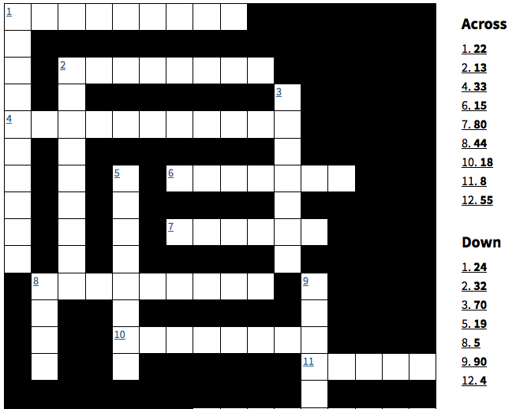
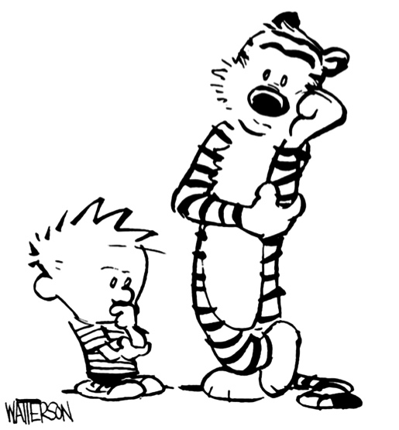
C: Correct the spelling mistakes in the following numbers.

SERO FOURTY FORTIFOUR

FIFE FIVTY TWELFE

FIFETEEN EITY FIRTY

TWENTYONE ONE HUNDERD ONE TOUSEND

