**Feelings**

**A : Do a repetition of the adjectives you learnt in this unit. Write a sentence next to each picture using one of the adjectives of the list!**

afraid, aggressive, bored, calm, friendly, frightened, tired, nervous, confident, excited, curious, shy, in love, cheerful, relaxed, angry

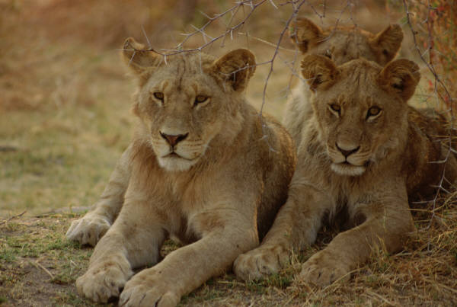 _________________________________________________

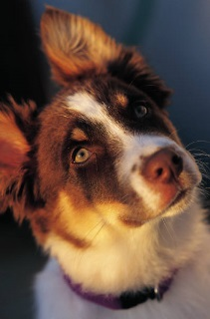 _________________________________________________

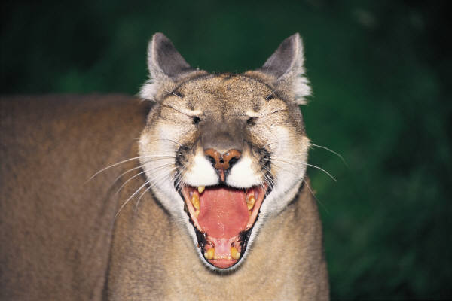 _________________________________________________

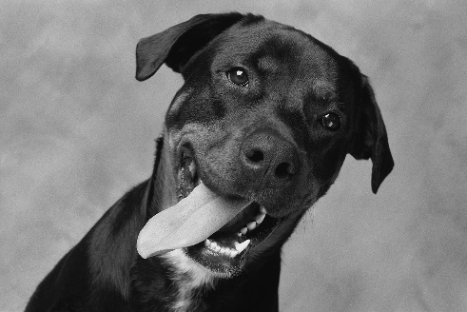 _________________________________________________

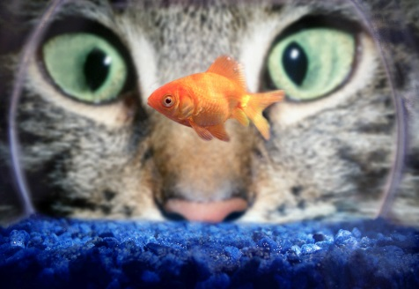 _________________________________________________

 __________________________________________________ _________________________________________________

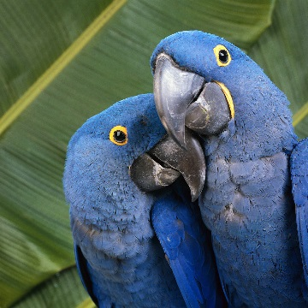 _________________________________________________

 _________________________________________________ _________________________________________________

**B: Look at the faces below. What feelings do they express?   
Write them in German and translate them with the help of a dictionary, your class mates or the teacher.**

