Repetition of past simple
A: Underline all the verbs in past tense
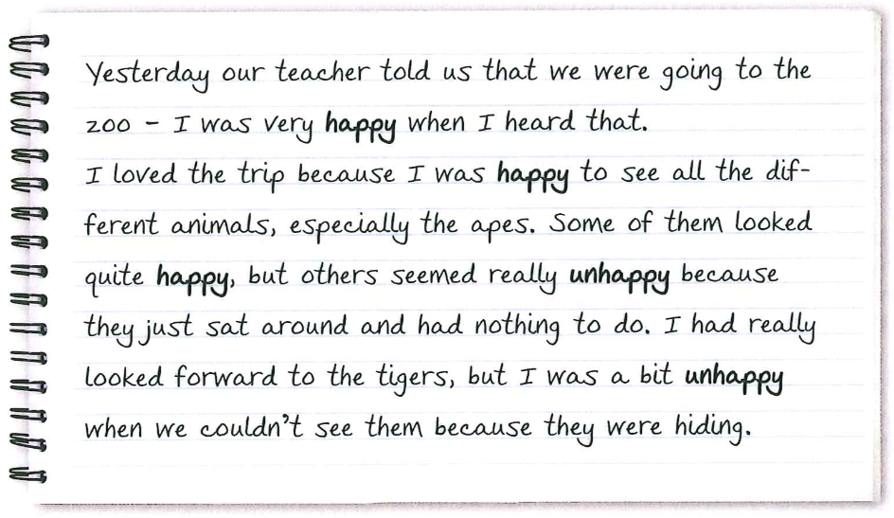
B: Write down the verbs here in infinitive (Grundform)
told: tell________________________________________________________________________
_________________________________________________________________________________
_________________________________________________________________________________
_________________________________________________________________________________
_________________________________________________________________________________

Solution:
told: tell looked: look counldn’t: can’t
was: be (am/are/is) seemed: seem were: be (am/are/is)
heard: hear sat: sit
loved: love had: have

