Communicating with apes
Read the text about Sue Savage- Rumbaugh and answer the questions below.
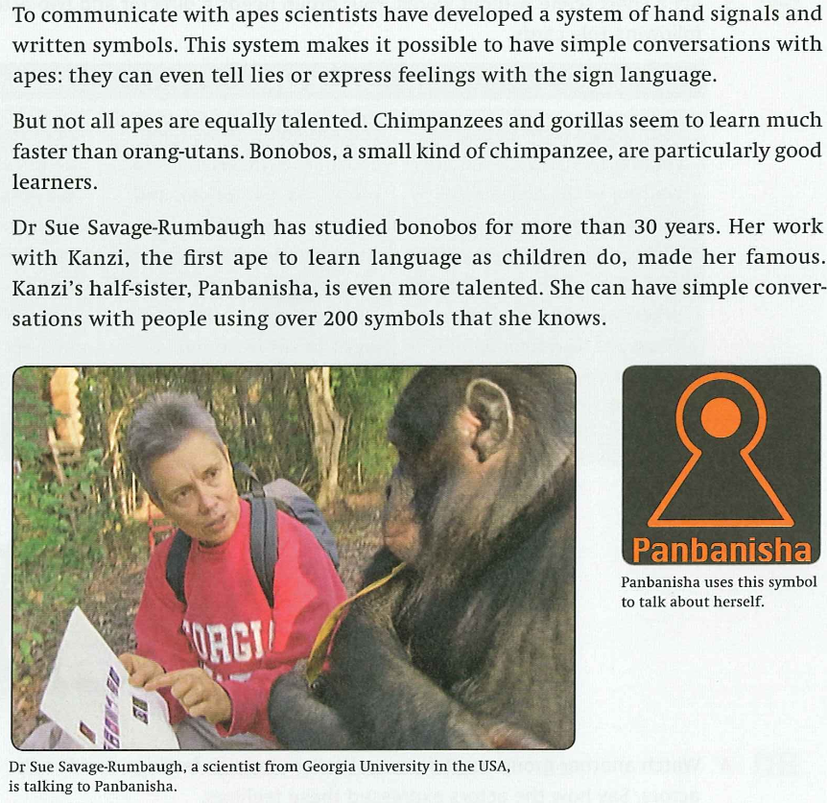
Write (T) for true and (F) for false!
1. Sue Savage- Rumbaugh’s first name is Georgia?
2. Sue Savage- Rumbaugh got famous for her work with Panbanisha.
3. Orang-utans are the most talented apes for learning language.
4. A bonobo is a kind of ape.
5. Chimpanzees can express feelings by using the chart with written symbols?
6. Chimpanzees can tell a lie by using the chart with written symbols?
7. Kanzi was the first ape who could speak to Sue Savage- Rumbaugh.
8. Panbanisha is from the same family than Kanzi.
9. Kanzi was more talented for learning language than Panbanisha is.

Solution:
1: F 4: T 7: T
2: F 5: T 8: T
3: F 6: T 9: F

