My grandmother’s cat
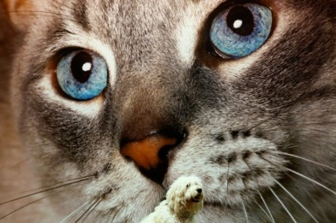

Find as many expressions as possible using the whole ABC.
The winner is the group who finish first.

1. My grandmother’s cat is a(n) angry cat.
beautiful/boring
c …………………………………….
d………………………………………
………………………………………..
………………………………………..
………………………………………..
………………………………………..
………………………………………..
………………………………………..
………………………………………..
………………………………………..
………………………………………..
………………………………………..
………………………………………..
………………………………………..
………………………………………..
………………………………………..
………………………………………..
………………………………………..
………………………………………..
………………………………………..
………………………………………..
………………………………………..
………………………………………..
………………………………………..

My grandmother’s cat

Find as many expressions as possible using the whole ABC
The winner is the group who finish first.

2. My grandmother’s cat likes apples.
brownies/books
c ……………………………………….
d…………………………………………
………………………………………….
………………………………………….
………………………………………….
………………………………………….
………………………………………….
………………………………………….
………………………………………….
………………………………………….
………………………………………….
………………………………………….
………………………………………….
………………………………………….
………………………………………….
………………………………………….
………………………………………….
………………………………………….
………………………………………….
………………………………………….
………………………………………….
………………………………………….
………………………………………….
………………………………………….

My grandmother’s cat (Possible solution)

1. My grandmother’s cat is a(n) angry cat.
beautiful/big
curious/cute/crazy/cool
delicate/dirty
excited/elegant
fat/friendly
good/gorgeous
happy
interesting/impolite
jolly
kind
lazy/loud
meowing/mean
nice
old
pretty/proud
quiet
relaxed/red
sweet/shy
tired/tough
unique
vicious
wonderful/wild
xenophobic
young
zany

My grandmother’s cat (Possible solution)

2. My grandmother’s cat likes apples
boots
chocolate
dogs
eggs
fish
gardens
ham
insects
jokes
kiwis
lions
milk
nights
owls
pizza
questions
roses
soup
toys
umbrellas
vanilla ice-cream
water
xylophones
yo-yos
zoos

