Present continuous

A: Fill in what is missing

Positive statements Negative statements

I ___ (____) walk____ I ___ ____ walk____
you ___ (____) play____ you _____ play____
he, she, it ___ (____) div____ he, she, it _____ div____
we ___ (____) wait____ we _____ wait____
you ___ (____) ski____ you _____ ski____
they ___ (____) run_ ____ they _____ run_ ____

Questions Short answers
____ I walk____?  ____ you play____?  ____ he, she, it div____?  ____ we wait____?  ____ you ski____?  ____ they run_ ____? | positive  Yes, _____ ____ .  Yes, _____ ____ .  Yes, _____ ____ .  Yes, _____ ____ .  Yes, _____ ____ .  Yes, _____ ____ . | negative  No, _____ ______ .  No, _____ ______ .  No, _____ ______ .  No, _____ ______ .  No, _____ ______ .  No, _____ ______ .
B: Answer the following question in GERMAN or ITALIAN.

When do we use the present continuous?

___________________________________________________

C: Describe the pictures in one sentence.

_______________________________________________________________
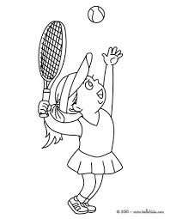

_______________________________________________________________

_______________________________________________________________

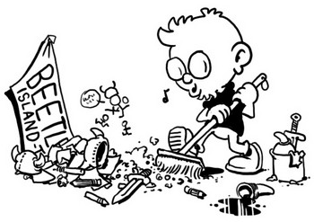

_______________________________________________________________

D: Describe what the people in the picture are doing.
ex. Mr. Martin is driving the bus.

walk play play music buy sell carry work drive dig take sit

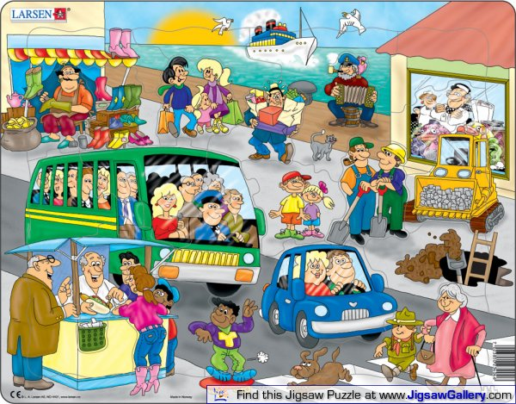

1.
2.
3.
4.
5.
6.
7.
8.

