Sample test exercises: listening

A: Test your listening skills – Chimpanzees (Lernkontrolle Unit 2 – eher für Niveau G)
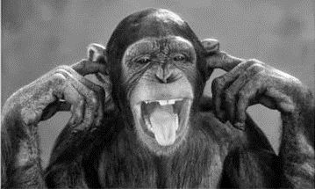
You are going to hear a text about chimpanzees. Read the sentences and mark the keywords. Listen to the text and decide for each statement if it is true (T) or false (F).
You will hear the text twice.

Underline the keywords that you hear in the text!
1) Chimpanzees can look carefully at one thing at a time because ⃝ T ⃝ F
their eyes are on the front of their face.
2) Their large eyebrows protect their eyes. ⃝ T ⃝ F
3) Chimpanzees can easily find food because they see well. ⃝ T ⃝ F
4) Their ears are small. ⃝ T ⃝ F
5) Monkeys and chimpanzees don’t have tails. ⃝ T ⃝ F
6) Chimpanzees use their long fingers to pick things up. ⃝ T ⃝ F
7) Chimpanzees can hang on to trees really well because they ⃝ T ⃝ F
have claws.
8) Chimpanzees aren’t clever enough to solve problems. ⃝ T ⃝ F
9) Young chimpanzees learn different skills from their parents. ⃝ T ⃝ F
10) Chimpanzees find food with sticks. ⃝T ⃝ F

Solution:
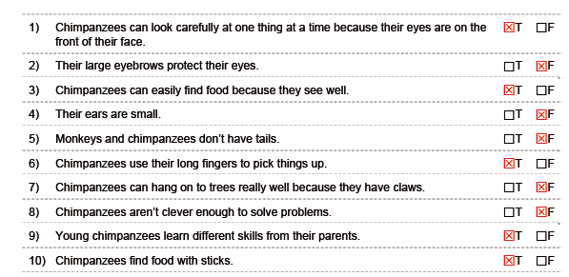
B: Listen to the information about chimpanzees and answer the questions below. Circle the correct answers. (Es können keine Antwort, eine Antwort, zwei Antworten oder drei Antworten richtig sein)
(Listening von Aufgabe 2b, Coursebook page 25 – eher für Niveau E)

1. When a chimpanzee plays, …
a) it has an open smile b) it shows its teeth c) it has the top teeth covered

2. What does it mean if its hair stand on end?
a) The chimpanzee is exited b) The chimpanzee is afraid d) The chimpanzee is aggressive

3. What does a chimpanzee normally do when it is aggressive?
a) it makes loud sounds b) its hair stand on end c) it raises its arms

4. How many different types of call can a chimpanzee normally produce?
a) 5 b) 15 c) 50

5. What kind of sound do chimpanzees do when they play?
a) meow b) hiss c) purr

6. Why is body contact so important for chimpanzees?
a) for preserving harmony b) for controlling their feelings c) because they groom each other

7. A chimpanzee uses different ways of communication. Which ones?
a) body language b) facial expression c) sounds

Solution:
1. a, b
2. a, b
3. c
4. b
5. no correct answer
6. a
7. a,b,c

