**Sample test exercises: Reading**

**A: Read this article and tick the right answer. Sometimes two answers are possible.**

The act of giving out and receiving information is called communication. A dog's bark may be either a sign of warning or welcome; the meow of a cat may indicate hunger or loneliness. A pet owner can tell animals something by means of spoken or visual signs that the animal has learned to recognize. Some animals, particularly chimpanzees, have been taught to communicate with people through such devices as sign language and symbols.

Communication is…

1. singing a song
2. sending information
3. giving hand signs

A dogs bark shows…

1. anger
2. happiness
3. loneliness

A cat…

1. twitters
2. barks
3. meows

Which animal has learned to communicate through symbols?

1. Cats
2. Apes
3. chimpanzees

wordlist

|  |  |  |  |
| --- | --- | --- | --- |
| the act | der Vorgang | to be called | genannt werden |
| to give out | aussenden | to indicate | zeigen |
| to receive | erhalten | by means of | mit Hilfe von |
| to recognise | erkennen | have been taught | wurden gelehrt |

**B: Read the text and fill in the chart with ticks, crosses and colors. (**[***www.eslprintables.com***](http://www.eslprintables.com)***)***

|  |  |  |  |  |  |  |  |  |
| --- | --- | --- | --- | --- | --- | --- | --- | --- |
|  | happy | sad | clothes | sitting | drinking | reading | cleaning | swimming |
| Mike | 🗶 | ✓ | blue | 🗶 | 🗶 | 🗶 | ✓ | 🗶 |
| Grandmother |  |  |  |  |  |  |  |  |
| Mr. Green |  |  |  |  |  |  |  |  |
| The girls |  |  |  |  |  |  |  |  |
| Paul |  |  |  |  |  |  |  |  |
| The birds |  |  |  |  |  |  |  |  |

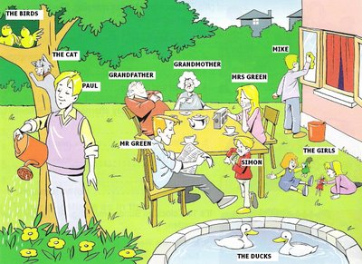  
  
  
  
  
  
  
  
  
  
  
  
  
  
  
  
  
  
  
  
  
2) Write T (True) or F (False) in the blanks.  
  
1) Paul is watering the flowers. _____  
2) The girls are playing with the balls. _____  
3) The ducks are swimming. ______  
4) Simon is happy. ______

This is my family. We live in a big house. Can you see Mike in the picture? He has got blue trousers. He is cleaning the window. He is sad. Grandmother is sitting. She is drinking tea. She’s wearing blue. She is happy. Mr. Green is sitting and reading the newspaper. He is happy. He has got blue trousers. The girls are sitting and playing with dolls on the floor. They are happy. They are wearing pink and blue. That is Paul. He’s watering the flowers. He has got blue and purple clothes. He is happy. Oh! Look at the beautiful ducks! They’re swimming in the small pool. And can you see the happy birds? They are sitting on the tree.

**C: Read the text about Sue Savage- Rumbaugh and answer the questions below.**

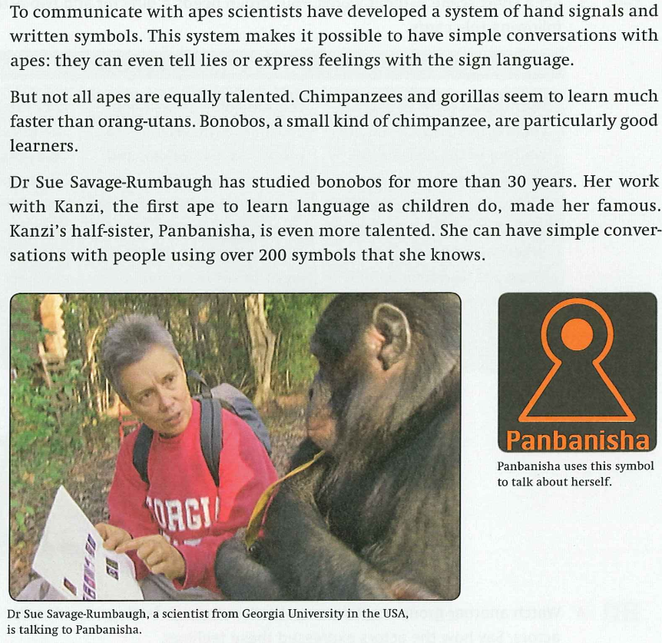

**Write (T) for true and (F) for false!**

1. Sue Savage- Rumbaugh’s first name is Georgia?

2. Sue Savage- Rumbaugh got famous for her work with Panbanisha.

3. Orang-utans are the most talented apes for learning language.

4. A bonobo is a kind of ape.

5. Chimpanzees can express feelings by using the chart with written symbols?

6. Chimpanzees can tell a lie by using the chart with written symbols?

7. Kanzi was the first ape who could speak to Sue Savage- Rumbaugh.

8. Panbanisha comes from the same family than Kanzi.

9. Kanzi was more talented for learning language than Panbanisha is.

Solution:

1: F 4: T 7: T

2: F 5: T 8: T

3: F 6: T 9: F

**D: Read the passage. Then answer the questions below.**

**Spider Webs**

All spiders spin webs. That's because webs help spiders. Webs help spiders do three things. Webs help spiders hold eggs. Webs help spiders hide. And webs help spiders catch food.

Webs help spiders hold eggs. Many spiders like to lay their eggs in their webs. The webs help keep the eggs together. Webs help spiders keep their eggs safe.

Webs help spiders hide. Most spiders are dark. They are brown, grey, or black. But spider webs are light. They are white and cloudy. When spiders hide in their webs, they are harder to see.

Webs help spiders catch food. Spider webs are sticky. When a bug flies into the web, it gets stuck. It moves around. It tries to get out. But it can't. It is trapped! Spiders can tell that the bug is trapped. That's because spiders feel the web move. And the spider is hungry. The spider goes to get the bug.

As you can see, webs help spiders hold eggs. Webs help spiders hide. And webs help spiders catch food. Without webs, spiders would not be able to live like they do. Spiders need their webs to survive!

**1)** This passage is mostly about

A. spider colours

B. spider webs

C. spider eggs

**2)** Spider webs help spiders

A. hold eggs

B. catch food

C. find water

A. I only

B. I and II only

C. I, II, and III

**3)** As used in paragraph 4, the word **trapped** nearly means

A. stuck

B. hidden

C. eaten

**4)** How can spiders tell when something is trapped in their web?

A. They hear it.

B. They smell it.

C. They feel it.

**5)** As used in the last sentence of the passage, the word **survive** means to stay

A. alive

B. hidden

C. caught

**6)** The passage lists three reasons why spiders spin webs. Of these reasons, which do you think is the most important? How come?

**7)** Do you like spiders? Why or why not? Have you ever been scared by a spider? Have you ever been hurt by one? Have you ever helped one? Explain.

**8)** Are spiders good? Do we need them in our world? Why or why not?