Sample test exercises: vocabulary

A: Choose the word which fits best (am besten passt) (Wörter von 3 und 4 nicht im Voci)

The dog _________________ when he sees a cat.
a) meows b) twitters c) barks d) purrs

I was very _________________________ about going to the match.
a) excited b) lazy c) realaxed d) deaf

Meeting the Germein sisters was a great ____________________
a) habit b) gesture c) expression d) experience

Do all these books really _____________________ my grandfather.
a) possession b) belong to c) talented d) order

B: Underline the odd word out (unpassendes Wort unterstreichen). (Nicht alle Wörter im Voci)

often | never | shy | generally | usually
bark | twitter | call | meow | chirp
body language | sign language | voice | gesture | connection
anxious | dive | glad | friendly | bored

C: For each of the following words, write a sentence that makes its meaning clear.

a) relaxed | b) shy | c) chimpanzee | d) scientist
________________________________________________________________________________________________________________________________________________________________________________________________________________________________________________________________________________________________________________________________________

D: Complete the passage using the words from the list. (Nicht alle Wörter im Voci, aber in der Unit wichtig)

together excited smile face play express another generally grins

A chimpanzee can __________________ different feelings with its ___________ .
It ____________ or sneers when ______________ or afraid. To impress _________________ chimpanzee it presses its lips __________________ .
When they _____________ , chimpanzees ________________ have an open ____________ with their top teeth covered.

E: Find the spelling mistake in each word and correct it.

a) curios _____________ | b) excitet _____________ | c) chimpanze_____________
d) disapointed _____________ | e) body languge____________ | f) usualy _____________

F: Describe the photos with the appropriate (passenden) adjective.
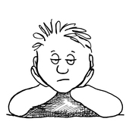  ________________________  ________________________ | 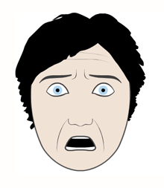  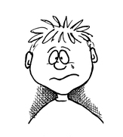  ________________________  ________________________ | 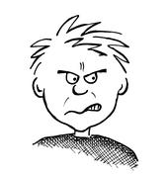  ________________________  ________________________

G: Sort the following words into three groups: verbs, nouns and adjectives. (Nicht alle Wörter sind im Voci, für diese Aufgabe aber bei E trotzdem machbar)

disappointed – sign – raise – call – connection – cheerful – deal with – shy – throat – hum – tail – similar – voice – dive – curious – talented – visit – order

nouns | verbs | adjectives

H: Adjectives for feelings: Complete the words!

h__p__y f__i__h__e__e__ l__z___ ___l___d
r__l__x__d __n___r___ t__r__d c__n__i__e__t

I: Change the words happy and unhappy. Use some of the words from the list below.

sad excited calm
bored curios nervous
aggressive relaxed tired
afraid shy confident

A family trip
Yesterday I was really happy_______________. My father told us that we were going on a family trip. He was happy ________________ to spend a day with his family. I was so happy __________________that I couldn’t sleep all night. In the morning my brother was unhappy ___________________because he couldn’t take the dog on the trip. We took the train. A lot of people were in the train and my mother was unhappy _________________ because she didn’t have to drive the car. My sister was so happy ________________ that she couldn’t sit still on her seat. We went to Bern. A lot of people got off the train there. They looked unhappy ______________________. I was happy ______________________ to see the big city. My little sister was unhappy ___________________ because she didn’t sleep enough.

