Sample test exercises: writing

A: Describe the pictures and use these verbs below. Write at least two sentences for each picture and use the present continuous.

lie put take a walk sit eat look
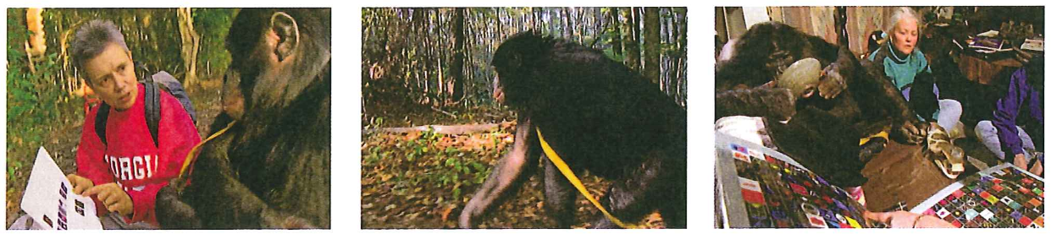

Picture 1:
________________________________________________________________________________________________________________________________________________________________________________________________________________________________________________________________________________________________________________________________________

Picture 2:
________________________________________________________________________________________________________________________________________________________________________________________________________________________________________________________________________________________________________________________________________

Picture 3:
________________________________________________________________________________________________________________________________________________________________________________________________________________________________________________________________________________________________________________________________________

B: Lernkontrolle von Unit 2: Test your writing skills
You have described scenes in a film or a picture as well as in a role play using the present continuous. Now describe the scene in this picture.
Du hast Szenen aus einem Film, auf einem Bild und in einem Rollenspiel beschrieben und dabei das present continuous angewendet. Beschreibe nun die Szene auf dem Bild.
a) What is going on in the park? Write at least 8 sentences.
Was geht im Park vor sich? Schreibe mindestens 8 Sätze.
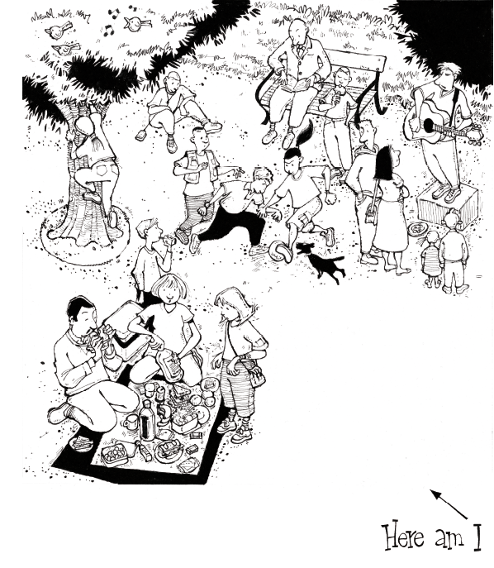

b) Now imagine you are in the park. What are you doing? Draw a picture of yourself into the illustration. Write at least 2 sentences about yourself. Use verbs you know.
Stell dir dich selbst im Park vor. Was machst du gerade? Zeichne dich selber und schreibe 2 Sätze über dich. Brauche Verben, die du kennst.
a) ________________________________________________________________________________________________________________________________________________________________________________________________________________________________________________________________________________________________________________________________________________________________________________________________________________________________________________________________________________________________________________________________________________________________________________________________________________________________________________________________________________________________________________________________________________________________________________________________________________________________________________________________________________________________________________________________________________________________________________________________________________________
b) ________________________________________________________________________________________________________________________________________________________________________________________________________________________________________________________________________________________________________________________________________
Beurteilung
In the park |  | 1 | 2 | 3
message | Du beschreibst die Hauptelemente des Bildes in verständlichen Sätzen. |  |  |  | x2
structure | Du wendest die in der Unit gelernte Zeitform des present continuous richtig an. |  |  |  | x2
vocabulary | Du kennst genügend Verben, um die Handlungen der Personen wiederzugeben. |  |  |  | x1
accuracy | Deine Sätze sind grösstenteils richtig strukturiert. Die meisten Wörter aus dem bekannten Wortschatz sind richtig geschrieben. |  |  |  | x1
Total: / 18
Kommentar

C: Test your writing skills.
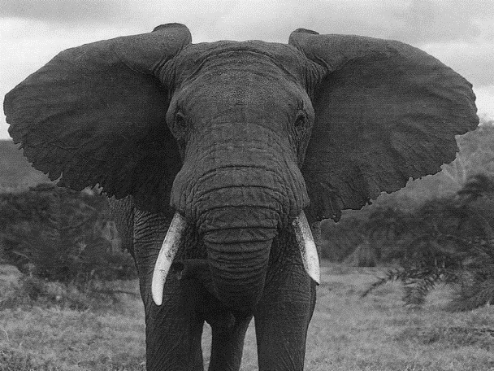
Put the paragraphs of the text about elephants into the correct order.
Look out for keywords connecting the
beginnings and endings of each paragraph. Then write an introductory sentence for each paragraph. Mark the keywords in each paragraph.

1
____________________________________________________________________________
The larger of the two kinds is the African elephant; the smaller is the Asian elephant. Elephants live in grasslands, marshes, forests and deserts. They are found in Africa and many Asian countries including India, Sri Lanka, Malaysia, Indonesia and the south of China.

____________________________________________________________________________
They do not use their trunk only to eat grasses; they also use it to hold and break off a branch and then to put the branch in their mouth. When they are thirsty, they take in water through their trunk, and when they are hot they can use it to suck up water and throw it over their body to cool down. By touching other elephants with their trunk or smelling them elephants can communicate with each other. These intelligent animals even communicate sadness when one of them dies.

____________________________________________________________________________
In both Africa and Asia, groups of eight to twelve females typically live together with the baby elephants. Only male elephants, or ‘bulls’ as they are called, may live alone or in male-only herds. After the birth of a baby elephant, the females in the herd will touch and sniff the new elephant to welcome it into the family. All the elephants in the herd – which is led by the oldest, most experienced female elephant – help to bring up the young.

____________________________________________________________________________
A healthy elephant does not usually die young and they can live to be about 70 years old. They are safe from all other animals because they are so big and strong. But sadly they are not safe from humans, who still hunt elephants for their tusks in some places. This is why the elephant is an endangered species today. It would be very sad if one day there were no wild elephants left in Africa and Asia!

____________________________________________________________________________
To get enough energy for these huge bodies, they regularly need to eat large amounts of food. They can reach most of their food – such as tree bark, leaves and branches – with their long trunk, which is a continuation of the nose and upper lip. The trunk is also able to reach the ground, so elephants can eat grasses.

____________________________________________________________________________

Baby elephants are less than a metre tall, but when they grow older they reach a height of three to four metres. Their huge bodies need a lot of support. Inside their massive legs are thick, strong bones. The wide, round feet carry the elephant’s weight and spread it out. This allows elephants to move quietly, leaving hardly any tracks.

