**Vocabulary training**

**A: What are these people feeling? Write an adjective next to each picture!**

Bonus: Write a sentence using ”I think he/she is… because / because of the way …”

 ________________________________________________________________

 ________________________________________________________________

 ________________________________________________________________

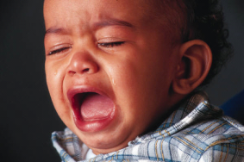 ________________________________________________________________

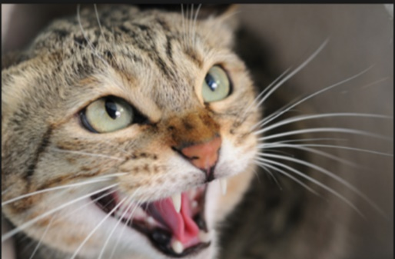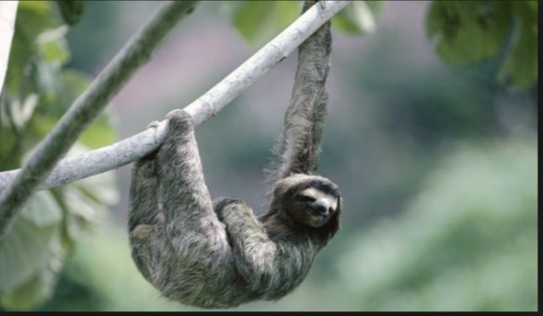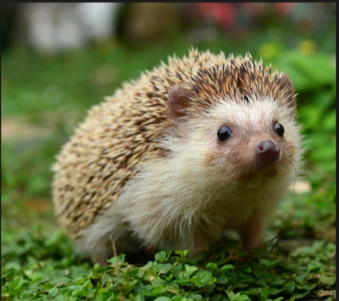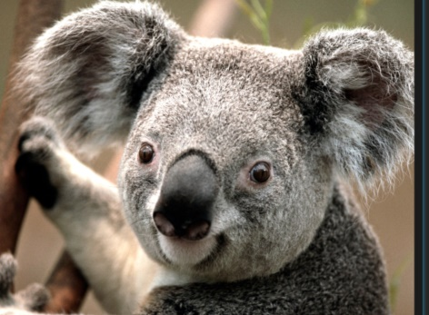**B: Look at the pictures. What are the animals feeling? Write the pictures’ number next to the adjective**

4

3

2

1

curious nr.:______

happy nr.:_______

agressive nr.:________

lazy nr.:____________

**C: Order this vocabulary in four word groups.** (Wörter teilweise nicht im Voci, aber in der Unit)

grin, smile, throat, chimpanzee, ape, confident, twitter, purr, budgie, meow, tail, face

|  |  |  |  |
| --- | --- | --- | --- |
| animals | feelings | sound | body part |
|  |  |  |  |
|  |  |  |  |
|  |  |  |  |

**D: Describe the smily’s emotions.**

|  |  |  |  |
| --- | --- | --- | --- |
| * http://smileys.smileycentral.com/cat/36/36_2_60.gif | [Sickly](http://www.smileycentral.com/?partner=ZSzeb001_ZS) | http://smileys.smileycentral.com/cat/13/13_4_10.gif | [Grrr](http://www.smileycentral.com/?partner=ZSzeb001_ZS) |
|  |  |  |  |

|  |  |  |  |
| --- | --- | --- | --- |
| http://smileys.smileycentral.com/cat/36/36_2_18.gif | http://www.mouserunner.com/ShinySmileys/ShineySmileysOriginalFull.png | http://smileys.smileycentral.com/cat/36/36_2_27.gif | [Shiver](http://www.smileycentral.com/?partner=ZSzeb001_ZS) |
|  |  |  |  |

|  |  |  |  |
| --- | --- | --- | --- |
| http://smileys.smileycentral.com/cat/36/36_2_63.gif | smiley | http://www.mouserunner.com/ShinySmileys/ShineySmileysOriginalFull.png | http://smileys.smileycentral.com/cat/7/7_4_17.gif |
|  |  |  |  |

**E: What do you feel when…**

When I cry I am .

At Christmas I am .

A chimpanzee is when another chimpanzee attacks him.

I am at my birthday.

I am when I don’t eat all day.

**F: Which animal is meant? Write them on the lines.** (Gesuchte Wörter nicht im Voci)

|  |  |
| --- | --- |
| Which animal gives us milk? |  |
| Which animal gives us eggs? |  |
| Which animal has a long nose? |  |
| Which is the biggest animal in the world? |  |
| Which animal eats bananas? |  |
| Which animal has a long neck? |  |
| Which bird lives at the South Pole and can’t fly? |  |
| Which animal lives at the North Pole? |  |

Describe these animals in one sentence.

dog

cat

horse

snake

pig

**G: Unscrumble the words**

A chimpanzee can express _______________ (ideffrnet) _________________ (gnefelis) with its face. It _________________ (igrns) or sneers when excited or afraid. To ________________ (iperssm) another chimpanzee it presses its lips together. When they play, chimpanzees generally have an open smile with their top teeth covered.

When a chimpanzee is _______________ (exteidc), its hair stands on end. This reaction can also mean that it is afraid. However, when it is aggressive it usually stares at another animal. It emphasises this with ________________ (grsusete) such as raising its arms or hitting the ground.

A chimpanzee normally produces more than 15 different types of call. For example, there is a special one to show its identity so its family can find it. When chimpanzees play they ______________ (teofn) make a sound ____________ (lrsaimi) to our laughter.

Body contact is very _________________ (tiopmtnar) for preserving harmony in a group of chimpanzees. That is why chimpanzees often groom each other for hours. It helps them stay ____________ (amcl) and creates feelings of friendship.

**Solutions**

A chimpanzee can express different feelings with its face. It grins or sneers when excited or afraid. To impress another chimpanzee it presses its lips together. When they play, chimpanzees generally have an open smile with their top teeth covered.

When a chimpanzee is excited, its hair stands on end. This reaction can also mean that it is afraid. However, when it is aggressive it usually stares at another animal. It emphasises this with gestures such as raising its arms or hitting the ground.

A chimpanzee normally produces more than 15 different types of call. For example, there is a special one to show its identity so its family can find it. When chimpanzees play they often make a sound similar to our laughter.

Body contact is very important for preserving harmony in a group of chimpanzees. That is why chimpanzees often groom each other for hours. It helps them stay calm and creates feelings of friendship.

1. gnefelis is feelings 6. alsywa is always

2. igrns is grins 7. teofn is often

3. exteidc is excited 8. tiopmtnar is important

4. iperssm is impress 9. grsusete is gestures

5. ideffrnet is different 10. amcl is calm

**H: Fill in the correct word. (Niveau G, Vocabulary parts « Introduction » and « How animals communicate »**

It is _________________ hot in July.

Is _________________ difficult to learn?

How was your holiday? You look _________________.

I watched a film about _________________ on TV.

You look _________________ – have you seen a ghost ?

Our cat _________________ goes outside after she has eaten.

I will _________________ this film so that we can watch it later.

I understood the film _________________ very well.

We _________________ go skiing in winter.

Can’t you hear me? Are you _________________?

What does this sign _________________?

Animals use _________________ to communicate.

She’s _________________ because I forgot her birthday.

His teacher had a long _________________ with his parents.

This music makes everybodey feel _________________ .

I’m so _________________ that we’re going to the cinema!

She wants to find out how dogs _________________.

Normally dogs are not _________________ .

Mobile phones make _________________ very easy.

I’m not _________________ of spiders !

What is your _________________ colour?

She can _________________ understand what her dog wants to say to her.

He never gets angry; he’s always very _________________.

**Vocabulary:**

Schimpanse / Kommentar / kommunizieren, sich verständigen / Kommunikation, Verständigung / Gespräch, Unterhaltung / taub / aufnehmen / Gebärdensprache, Zeichensprache / aggressiv / verärgert, wütend / Angst haben, sich fürchten / Körpersprache / ruhig, gelassen / fröhlich, vergnügt / aufgeregt, begeistert / Lieblings- / verängstigt / normalerweise, im Allgemeinen / bedeuten / normalerweise / oft / entspannt / gewöhnlich, normalerweise