Through a telescope – Part 1
A: Read (or listen to) the story in your coursebook on page 44 once. Answer then questions 1-3.
1. Who is Renia?
a) A girl from England b) A girl from Switzerland

2. Where is Renia at the moment?
a) She’s in England. b) She is in Switzerland.

3. What does she do in this country?
a) She is on holiday b) She goes to school.

B: Have a look at the pictures and the captions (Bildbeschreibungen) and answer the questions.

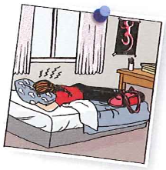
“She was so angry! She buried her head in the pillow.”
4. What do you think she is doing?
a) dreaming b) crying c) smiling

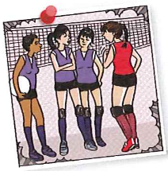
“Why don’t you like us?“ the girls on the team had asked her.“
5. What do you think : Which sport does Renia play ?
a) Rugby b) Volleyball c) Football

6. How many friends has Renia got in her team?
a) none b) one best girlfriend c) a lot of good friends

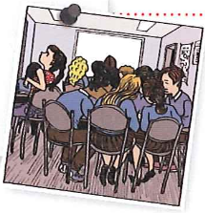
“In her host class everybody thought she was arrogant.”
7. Why do the people in her class don’t like Renia?
a) They think she is arrogant
b) They don’t understand her English.
c) There must be something else.

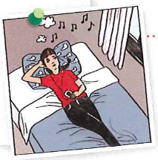
“She plugged in her favourite music and let her thoughts wander.”
8. What does this sentence mean in German?
a) Sie taucht ab, hört ihre Lieblingsmusik und geht wandern.
b) Sie steckt die Kopfhörer mit ihrer Lieblingsmusik in die Ohren und lässt ihren Gedanken freien Lauf (lässt die Gedanken herumwandern)

9. Why does she “let her thought wander?”
a) She want to find out why nobody likes her in England
b) She wants to go back to Switzerland.

Through a telescope – Part 1 – Unterrichtsidee für schwächere Schüler

Pre-reading:
Each student gets one little part of the text (e.g. a paragraph)
- Read your part of the text.
- Underline the words you don’t understand and look them up.
- Translate your part of the text.
- Draw three symbols that explain your text and write a sentence for each symbol.
- Give it a title.
Do this with the computer. Use the given layout.
Now read and listen to the text (2-3 paragraphs)
Each expert presents his 3 symbols and tells his sentences. He reads his translation.
Hang up the worksheets on the wall.
Title

Symbol 1 | Symbol 2 | Symbol 3

Sentence 1 | Sentence 2 | Sentence 3

