**Sample test exercises: writing**

**A: Write the sentences below in a more polite way.**

* 1. Help me with the washing up.

___________________________________________________________

* 1. Open the door.

___________________________________________________________

* 1. Tell me a story.

___________________________________________________________

* 1. Show me where the railway station is.

___________________________________________________________

* 1. I want a glass of milk.

___________________________________________________________

* 1. Help me with my homework.

___________________________________________________________

**B: Giving advice**

1. Imagine your neighbour is going to England. Which advices would you give him? Use should and shouldn’t to give four advices!

__________________________________________________________________________________

__________________________________________________________________________________

__________________________________________________________________________________

__________________________________________________________________________________

1. Your friend from Japan is visiting Switzerland. Give him four advices as well what he should or shouldn’t do in Switzerland.

________________________________________________________________________________________________________________________________________________________________________________________________________________________________________________________________________________________________________________________________________

**C: Expressing thank you.** Look at the sentences below and say “Thank you” in different ways.

1. A pupil lends his USB stick to you. You say:

___________________________________________________________

1. A teenager picks flowers for her mother. She says:

___________________________________________________________

1. A friend invites you to a party. You say:

___________________________________________________________

**D: Which school rules are important in our school? Give 4 advices that exchange students should know, if they visit us!**

a) _________________________________________________________________________  
b) _________________________________________________________________________  
c) _________________________________________________________________________

**E: Retell Renia’s story by using the pictures of the extra sheet.**

**Write at least two sentences for each picture.**

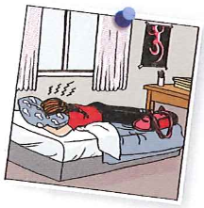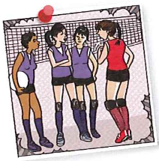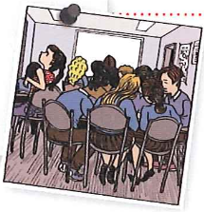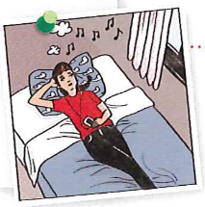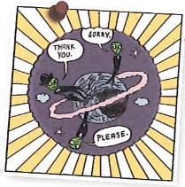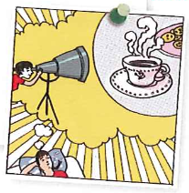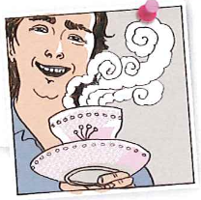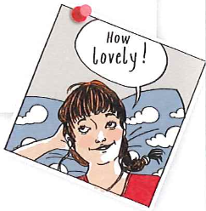

________________________________________________________________________________________________________________________________________________________________________________________________________________________________________________________________________________________________________________________________________________________________________________________________________________________________________________________________________________________________________________________________________________________________________________________________________________________________________________________________________________________________________________________________________________________________________________________________________________________________________________________________________________________________________________________________________________________________________________________________________________________________________________________________________________________________________________________________________________________________________________________________________________________________________________________________________________________________________________________________________________________________

|  |  |  |  |  |
| --- | --- | --- | --- | --- |
| **Content :** The student writes at least 2 sentences for each picture. | 1 | 2 | 3 | 4 |
| **Content :** The students retells the story correctly without missing any important parts. | 1 | 2 | 3 | 4 |
| **Language:** The student uses past tense correctly. | 1 | 2 | 3 | 4 |
| **Style:** The student writes complete sentences. | 1 | 2 | 3 | 4 |

**F: Renia and her feelings: Find two phrases and complete:**

a) Renia is ___________________ because she ____________________________ ___________________________________________________________________

b) Renia is ___________________ because she ____________________________

___________________________________________________________________

**G : Tips for Renia: What should she do? What shouldn’t she do? Make three suggestions.**

1. She ____________________________________________________________

2. She ____________________________________________________________

3. She ____________________________________________________________

**H : Writing: Renia’s story. Look at the pictures and answer the questions.**

Picture 1:

1. What do you see? Describe exactly? (2)

2. Give the picture a title. (1)

___________________________________________________________________

___________________________________________________________________

___________________________________________________________________

___________________________________________________________________

___________________________________________________________________

Picture 2:

1. What do you see? Describe exactly? (2)

2. Give the picture a title. (1)

___________________________________________________________________

___________________________________________________________________

___________________________________________________________________

___________________________________________________________________

___________________________________________________________________

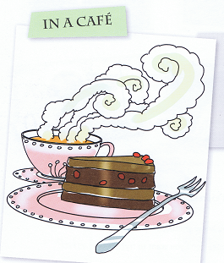**I: You’re in a café or in a restaurant. Write a short dialogue between you and the waiter.**   
___________________________________________________________________

___________________________________________________________________

___________________________________________________________________

___________________________________________________________________

___________________________________________________________________

___________________________________________________________________

___________________________________________________________________

___________________________________________________________________

___________________________________________________________________

___________________________________________________________________

___________________________________________________________________

___________________________________________________________________

___________________________________________________________________

___________________________________________________________________

___________________________________________________________________

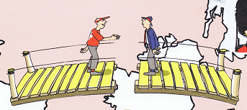**J: Describe the situation in 2-3 sentences!**

__________________________________  
__________________________________  
__________________________________  
__________________________________

__________________________________

__________________________________

______________________________________________________________________________________________________________________________________________________________________________________________________________________________________________________