The highest Buildings in the World
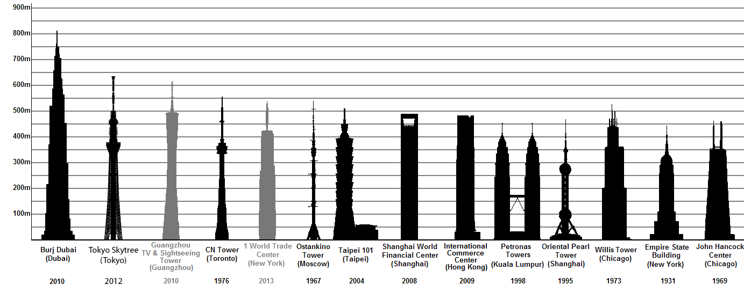

New York: These are the highest buildings

Nr. | name | official hight | levels | year of construction
1 | One World Trade Center | 541 m | 104 | 2014
2 | Empire State Building | 381 m | 102 | 1931
3 | 432 Park Avenue^{A1} | 426 m | 89 | 2015
4 | Bank of America Tower | 366 m | 55 | 2009
6 | Chrysler Building | 319 m | 77 | 1930
16 | Trump World Tower | 262 m | 72 | 2001

