Crazy Chunk Discussion
Spielanleitung:
Die Kärtchen werden gleichmässig unter den Schülern verteilt. Die Lehrperson startet die Diskussion mit einem Chunk, worauf die SuS mit einem passenden Chunk reagieren und so die Diskussion weiterführen. Es geht darum, einen Konsens zu finden, wohin die Gruppe am letzten Tag ihres NY Aufenthaltes noch gehen will.
I disagree with you because… | … I think the MoMA is the most interesting museum of NY
I think we should see … | … I think we should first visit … then …
I think we shouldn’t .. | … take a subway train to  Broadway. We can walk.
In my opinion we should visit… | … Broadway shows are the best ever.
I agree with you but … | … I think the theatre in Chur is pretty wow too.
What do you think about ….? | I think we should eat here before we go to …..
I disagree with you because… | … we have beautiful parks too.
In my opinion Central Park is the most beautiful park of all. | … also visit Times Square.
I think we should visit… | … a play in a Broadway theatre.
I agree with you but … | … I think they are too expensive.
What do you think about …? | I think we shouldn’t miss the chance of …….
I think we should… | …  …. is the …. of the world.
I disagree with you because… | … is better than…
In my opinion…. | … is nicer/taller/ higher/better  more modern/ beautiful than..
I agree with you but… | … I think that….
What do you think? | … in my opinion …. is …. than…
I think we shouldn’t… | … miss …. It’s just amazing!
Ground Zero 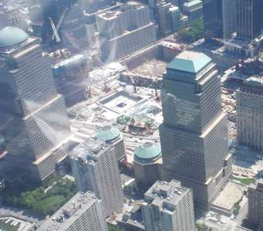 | Rockefeller Center 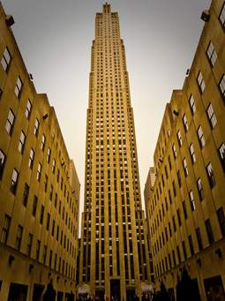
Central Park 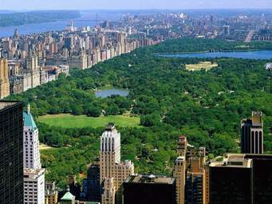 | Fifth Avenue  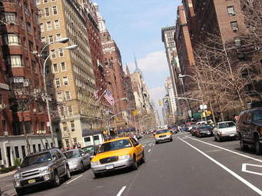
Times Square 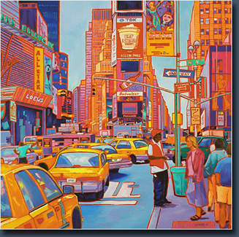 | Bryant Park 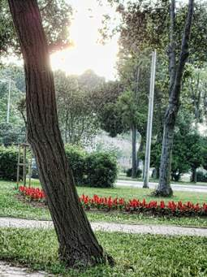
Brooklyn Bridge 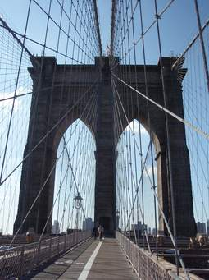 | American Museum of Natural History 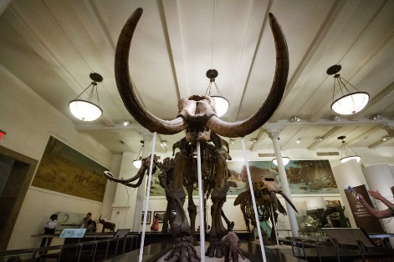
9/11 Memorial & Museum 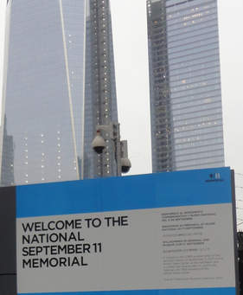 | Grand Central Terminal 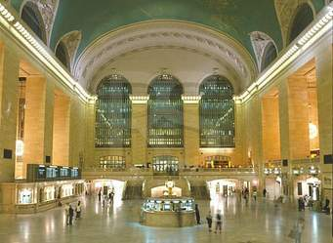
Bronx Zoo 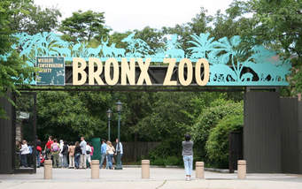 | Staten Island Ferry 