Comparison
Theorie
Steigerung mit -er/-est
 | Adjektiv | Komparativ | Superlativ
alle einsilbigen Adjektive | clean | cleaner | (the) cleanest
zweisilbige Adjektive, die auf y oder er enden | easy  clever | easier  cleverer | easiest  cleverest

Ausnahmen:
stummes e am Ende entfällt Beispiel: late-later-latest
y am Ende wird zu i Beispiel: easy-easier-easiest
Konsonant nach kurzem, betontem Vokal wird verdoppelt Beispiel: hot-hotter-hottest

Steigerung mit more – most
 | Adjektiv | Komparativ | Superlativ
alle mehrsilbigen Adjektive  (außer zweisilbige auf -y / -er) | difficult | more difficult | most difficult

Unregelmäßige Steigerung von Adjektiven
Adjektiv | Komparativ | Superlativ
good
bad
little (wenig)
little (klein)
much / many

A: Fill in the adjectives in the correct form.
New York City is the ______________(large) city in the United States. The ____________ (old) part of the city, the island of Manhattan, still has its original Lenape Native American name. Most of New York City is situated on three islands near the Atlantic Ocean, and one part is on the mainland of North America. The city includes the 3 _____________ (large) islands : Manhattan Island, Staten Island and the western end of Long Island. There are also many _____________ (small) islands.
In New York City there are about 5600 skyscrapers. 48 of them are _____________ (tall) than 200 metres, which is the _______________ (high) number of skyscrapers in one area in the world.
Subway transportation is provided by the New York City Subway system, one of the ___________ (big) in the world. Pennsylvania Station, the _____________ (busy) train station in the United States, is here, too.
John F. Kennedy International Airport, which is in the Queens neighbourhood of New York, is one of the ________________ (busy) airports in the United States.

B: Choose three buildings and compare them. Use the adjectives tall, modern, high, interesting and beautiful:
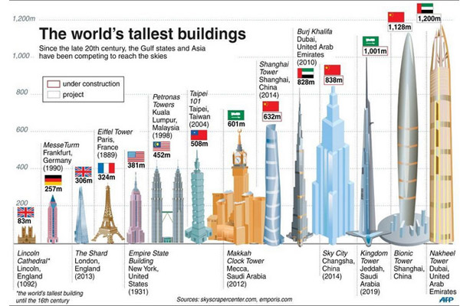

The Eiffel Tower is big. _____________ is ___________________.
The Empire State Building is bigger. _____________ is ___________________.
Burj Khalifa is the biggest. _____________ is the ________________.

______________________________________________________________________________________________________________________________________________________________________________________________________________________________________________________________________________________________________________________________________________________________________________________________________________________________________________________________________________________________________________________________________________________________________________________________________________________________________________________________________________________________________________________________________________________________________________________________________________________________________________________________________________________________________________________________________________________________________________________________________________________________________________________________________________________________________________________________________________________________________________________________________________________________________________________________________________
C: Look at these records and fill in the correct adjectives.
Source: Non Stop English, Zürcher Lehrmittelverlag

The ____________________ woman is 59 cm.
The ____________________ man is 2.72 metres.
The ____________________ man is 114 years old.
The ____________________ man is 538 kilos.
The ____________________ number of children (one mother) is 69.
The ____________________ woman is Angelia Jolie.
The ____________________ garage is for 9250 cars.
The ____________________ station is on 4766 metres.
The ____________________ student makes a 6 in every test.
The ____________________ hotel has 3200 rooms.
The ____________________ train is 6 kilometres.
The ____________________ Swiss is 213 cm.
The ____________________ hair is 792 cm.
The ____________________ animal is a worm of 54 metres.
The ____________________ perfume is 160.-/gramm.
The ____________________ car is a Cadillac of 21.93 metres.
The ____________________ bicycle is 22.24 metres.
The ____________________ paining was 53.9 mio $.
The ____________________ river in Europe is the Wolga (2688 km)
The ____________________ bird is the ostrich (Strauss)
The ____________________ baby was 57 kilos at the age of nine month.
The ____________________ animal is a falcon. It’s top speed is 350 km/h.

Do you want help? Here are the adjectives, which you have to put in the gaps.
fast tall long heavy
high beautiful large big
intelligent old expensive small

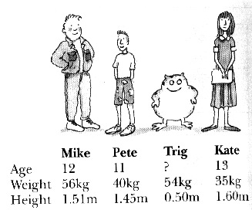
D: Write sentences about the four people in the picture. Check the example first.

e.g. Mike & Kate, age
Mike is younger than Kate___________________________
1. Kate & Pete, age
________________________________________________
2. Kate & Pete, weight
________________________________________________
3. Trig & Mike, height
________________________________________________
4. Kate & Trig, height
________________________________________________

Solution:
1. Kate is older than Pete
2. Kate is lighter than Pete
3. Trig is shorter than Mike
4. Kate is taller than Trig

E: Fill in the gaps with the correct form of comparison.

1. Nadine’s bag isn’t very big. She wants a ___________ bag.
2. This house isn’t very modern. I like ___________ houses.
3. Miss Forrer isn’t very tall. Mister Ackermann is ___________ .
4. Jean-Mathieu doesn’t work very hard. Sania works ___________.
5. The weather in Malans is not very beautiful. In Hawaii, it is ___________ .
6. Gian’s idea wasn’t very good. Fadri’s idea was ___________ .
7. Giulia is not very interested in cooking. She’s ___________ in dancing.
8. It isn’t very warm today. Yesterday it was ___________ .
F: Fill in the correct form of the words in brackets (comparative or superlative).
- This flower is _______________ than that one. (beautiful)
- This is the _______________ book I have ever read. (interesting)
- Which is the _______________ animal in the world? (dangerous)
- The weather this summer is even _______________ than last summer. (bad)
- Bikes _______________ are than cars. (cheap)
- January is _______________ than June. (cold)
- Sue is _______________ at English than her friend. (good)
- My shirt is than _______________ hers. (colourful)
- Alan's eyes are_______________ than Peter's. (big)
- Mount Everest is _______________ than K2. (high)
- Paula's hair is _______________ than Martha's. (long)
- Elephants are _______________ than giraffes. (heavy)

G: Which word is missing? Chose one and write it in the gaps.
Which girl is ________? Dana or Karen?  young, the youngest, younger, more young | Indian cooking has some of ________dishes in the world.  hot, the hottest, the hotter, hottest
Tomer is _________ boy in the class.  the strongest, stronger , strong, the most strong | That is ____________ song this band has.  the most beautiful, more beautiful, beautiful
The China Wall is _____ wall in the world.  the longest, more long, longer, long | Cities are ____________ than villages.  Busier, busy, the busiest, most busy
February is ______ than April.  short, the shortest, shorter, most short | Bill Gates is one of ___________ people in the world.  the rich, richer, rich, the richest
I am ______ at music than my old sister.  good, better, goodest, the best | Garfield is ___________ than Nemo.  the funniest, more funny, funnier, the funniest

H : Compare the following people. Write sentences using the adjectives in the box.

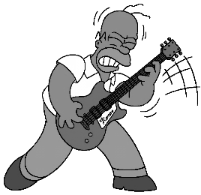
Bob | Homer | Alice
28 years old | 39 years old | 9 years old
55 kilos | 80 kilos | 33 kilos
1.55 mt | 1.55 mt | 1.20 mt

young old ugly beautiful intelligent tall long

