Sample test exercises: speaking
A: Asking the way (Dialogisches Sprechen)

Student 1: You are a tourist from England who is at the station in XXX.
1. Ask the way to .....

2. Ask how far it is.

3. Ask if you have to take the bus or if you can go on foot.

4. Ask if there is something interesting to see in town.

5. Thank the person for her/ his help.

Student 2: You are at the station in XXX. A tourist comes and asks you the way.
1. The tourist asks you the way. Explain the way.

2. The tourist asks you how far it is. Explain it.

3. The tourist asks you if he can take the bus or should walk.
Give him the information he needs.
4. The tourist asks you if there is something else to see.
Give a tip.

5. Say goodbye to the tourist.
B: Explain the way to…. (Monologisches Sprechen)
- the supermarket
- the church
- the shoe shop
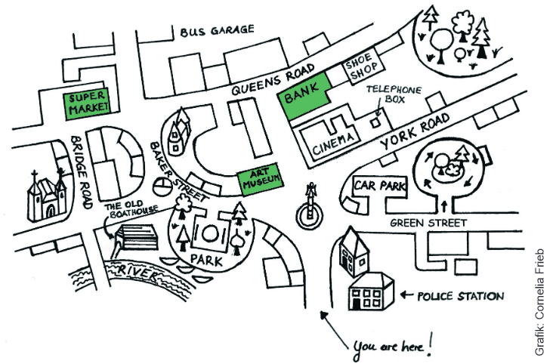

C: Choose one of the topics and prepare a little speech.
Times Square  - Midtown Manhattan  - Broadway  - famous for theatres  - theatre tradition  - no row “I” in the theatre – confusing with number 1. | Central Park  - green oasis  - 6% of the total area of Manhattan  - 38 million visitors every year  - run, walk, jog, play baseball, chess, go fishing  - 9000 benches
Statue of Liberty  - first glimpse of new life  - French sculptor – Frédéric Auguste Bartholdi  - opened in 1886  - walk up to the crown  - made of copper | The Museum of Modern Art (MoMA)  - located on 53rd Street  - most important museum of modern art  - 150’000 pieces, paintings, sculptures, photographs  - 3 million visitors a year  - 1958 fire on the second floor

D: PET- Speaking test: Sights in New York
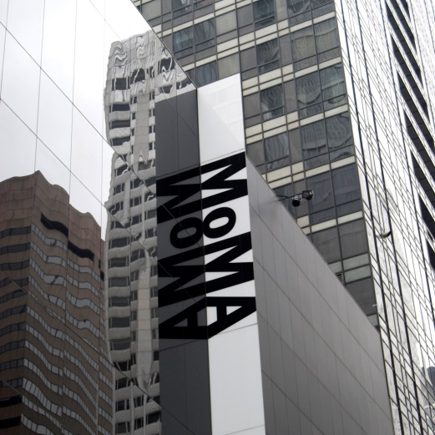
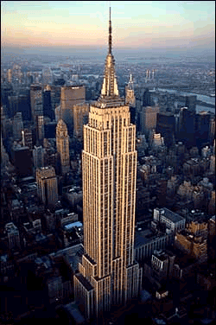
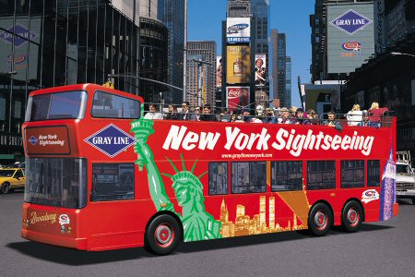
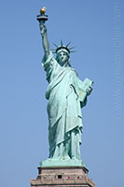
Sights of NYC - Museum of Modern Art
Sights of NYC - Empire State Building
Sights of NYC - Sightseeing Bus Tour
Sights of NYC - Statue of Liberty
Sights of NYC - Times Square
Sights of NYC - Central Park

It is your last day in New York City. Which sight do you and your friend want to visit?
Talk together about the different possibilities and decide which would be best.

