Vocabulary training
A : Fill in the gaps

a) He lives in the suburb of New York and has to ___________ by train for one hour every morning.
b) I went to a ___________ to do all my shopping.
c) The house was easy to see becuase of its _________.
d) Very tall buildings are called ________________
e) Turn left at the next ______________
Solution: commute, mall, height, skyscraper, crossing)

B: Translate (Achtung: gesuchte Wörter grösstenteils nicht im Voci, nur in der Unit)
English | Deutsch | Italiano
 | bauen | costruire
 | gefährlich | pericoloso
 | beide | entrambi
 | der Albtraum | l’incubo
 | der Biss | il morso
 | das Gebäude | l’edificio
 | der Maler | il pittore
 | gross, hoch | altro
 | der Schriftsteller | l’autore, lo scrittore
 | teilnehmen | partecipare

(Solution: build, dangerous, either/both, nightmare, bite, building, painter, tall, writer, take part in)

C: Sorting (Achtung: Viele Wörter nicht im Voci, sondern nur in der Unit)

neighbourhood, pros and cons, poet, contruct, design, suburb, argument, storey, writer, tower, painter, floor, background noise, storey

building | art
city life | opinion

building: skyscraper, storey, floor, tower, contruct
art: writer, poet, painter, design
city life: background noise, suburb, neighbourhood,
opinion : pros and cons, argument
D: Out and about New York City (G/E)

These are the words in American English. Search the words in British English with the same meaning.

parking lot downtown intersection
ground floor apartment yard
vacation elevator truck
cellphone freeway sidewalk
trash can cab subway
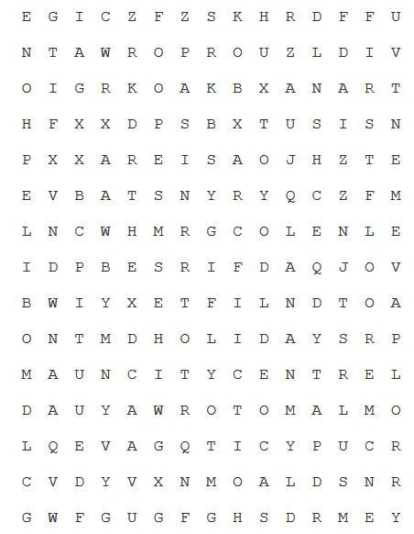

Solution :
E G + C + + + + K + R + F F +
N + A + R + + R + U + L D I +
O I + R + O A + B + A N + R T
H + X + D P S B + T U + + S N
P + + A R E I S + O + + + T E
E + + A T S N + R + + + + F M
L + C + H + + G + O + + + L E
I + + B + + R + + + A + + O V
B + I + + E T F I L + D + O A
O N + + D H O L I D A Y S R P
M + + N C I T Y C E N T R E L
+ + U Y A W R O T O M + + + O
+ + + + + + + + + + + + + + R
+ + + + + + + + + + + + + + R
+ + + + + + + + + + + + + + Y

