Communication is not easy

We thought nobody lived here, but today we saw some natives on the beach who were about to launch their canoe. Once in the water, the canoe came near the ship, but it didn’t come up close.

Even though we tried to show the people in the canoe that we were friendly and we waved with white cloth to show that we were not dangerous, the natives turned their canoe round.
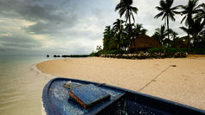
Captain Cook decided to visit these people in the afternoon, because he wanted to show that we would not hurt them. But we could not find them when we were ashore.

We left them some presents: Mirrors and beads.

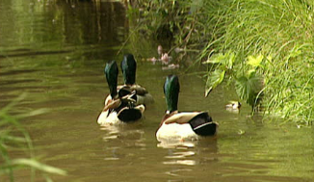
Then we left and rowed further along the cove, where we found ducks and birds on a stream flowing with fine fresh water.

After that, we rowed back to where we had left the presents and we even added an axe to the other things. But we still didn’t see anyone.
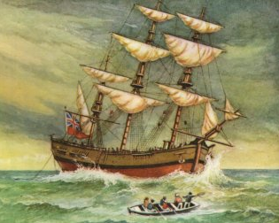
Captain Cook said we shouldn’t go into the jungle to look for the Indians. He said they would come out when they wanted to. So we returned to our ship.

