Describe people
Hight
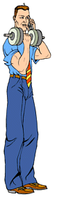 | 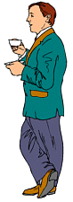 | 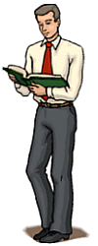
He is tall.  He is very tall. | He is short.  He is quite short. | He is average/ normal/ medium high.  He is relatively normal high.

Build
 | 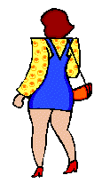 | 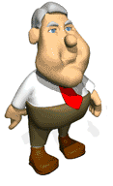
She is skinny. (negative)  She is anorexic. (medical)  She is underweight. (neg)  She is thin. (negative )  She is slim. (positive)  She is slender. (positive) | She is fat. (negative )  She is tubby. (negative)  She is overweight. (neg)  She is plump. (neutral)  She is stocky. (neutral)  She is bonny. (positive ) | Note! – if a man is fat (specially round the waist) we often say he has a beer belly.

Hair
blonde/ fair hair  blonde | brown hair  brunette | red hair  redhead | black hair | grey hair
Eyes
grey eyes | green eyes | blue eyes | brown eyes | dark eyes
Note! – This is a black eye:

Type of hair
She has long hair.  She has long, black, straight hair.  Her hair is long, straight and black. | She has short hair.  She has short, black hair.  She has short, straight, black hair. | He has no hair.  He is bald. | She has medium length hair. | She has medium lenth, wavy, red hair.  She wears glasses. | She has short hair.  She has short, curly, blond hair.

Type of complexion
 |  |  | 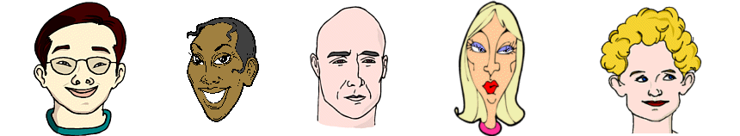
He is Asian. He has light-brown skin. | She is black. She has dark skin. | He is white. He has fair skin. | She is white. She has lightly tanned skin. | She is white. She has very pale skin.

Other features
moustage | beard | chin | forehad | nostrils

eyebrows | cheeks | fringe | lips | teeth

Some features (it may not be polite to mention them)
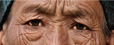 | 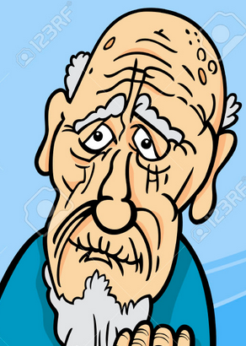 | 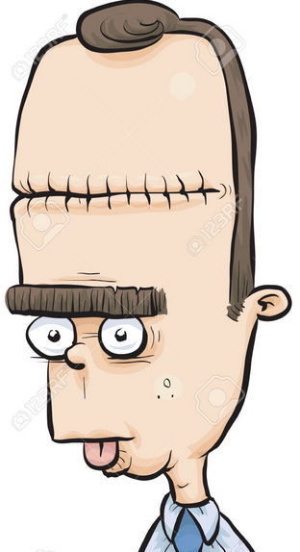 | 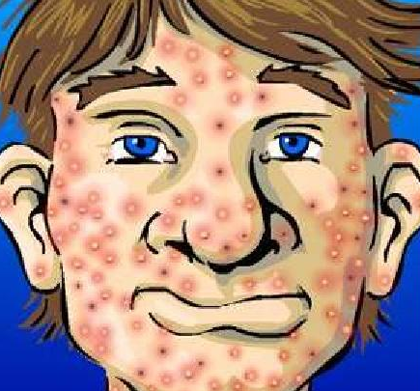
crow’s feet  laughter lines | wrinkles | scar(s) | spot(s)

Source: http://www.learnenglish.de/basics/appearances.html

A : Describe these people ! How old are they? What dothey look like? Write one sentence about each person.
Source : www.elcivics.com
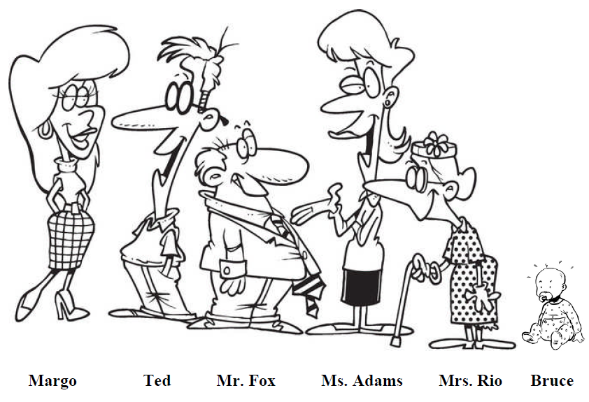
Margo
Ted
Mr. Fox
Ms. Adams
Mrs Rio
Bruce

