Sample test exercises: reading
A: Read the texts about modern explorers and answer the questions below. (eher für E)
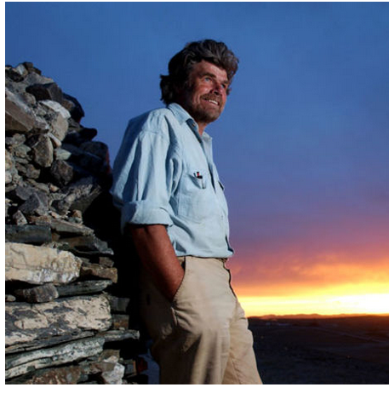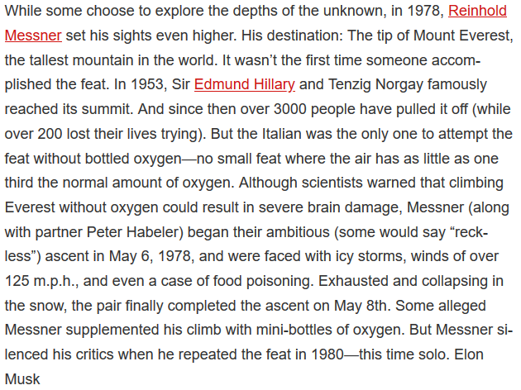

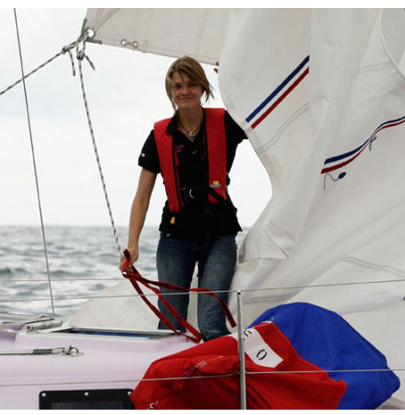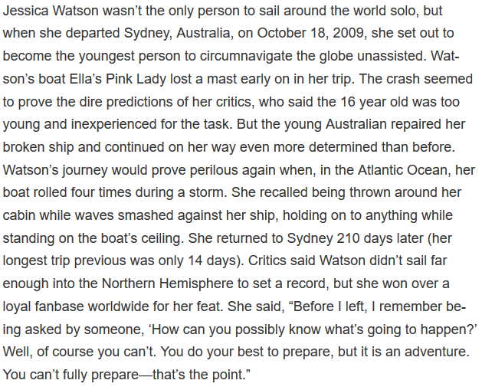
1. Fill in the table
 | Reinhold Messner | Jessica Watson
Nationality

What was his/ her achievement (Leistung)?

When did he/ she do this?

Both had to fight against different things during their trip. What went wrong?

Did everyone believe what they did? What did the critics say?

Solution:
 | Reinhold Messner | Jessica Watson
Nationality | Italian | Australian
What was his/ her achievement? | went to Mount Everest without oxygen | sailed around the world solo
When did he/ she do this? | 1978 | 2009
What went wrong during the trip? | icy storms, food poisoning | lost a mast, the boat rolled four times,
What did the critics say? | that he uses little oxygen bottles | that she didn’t sail far enough into the northern Hemisphere

B: Read the text about James Cook and answer the questions. (eher für E)
Source: http://www.biography.com/people/james-cook-21210409
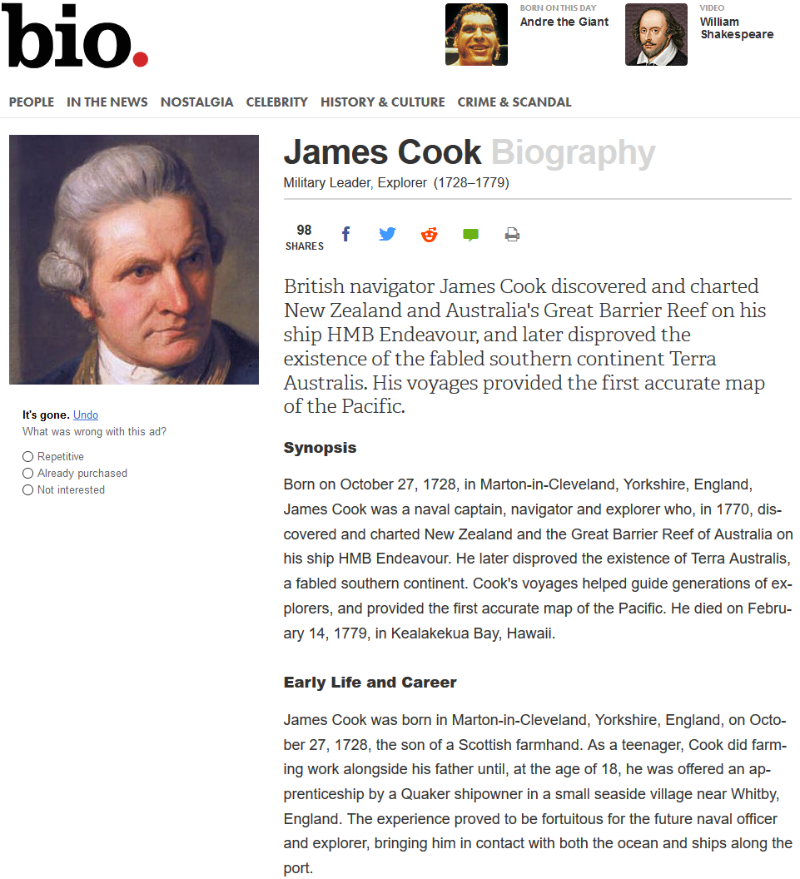

1. Tell me about his life. What happened in…
1728: ____________________________________________________________________
1756-63: ____________________________________________________________________
1770: ____________________________________________________________________
1779: ____________________________________________________________________
2. List all the regions and island James Cook discovered.
__________________________________________________________________________________
__________________________________________________________________________________
3. Are these statements true, false or don’t you get the answer in the text?
 | true | false | don’t know
Australia wasn’t known before James Cook sailed to the Great Barrier Reef.
James Cook had a happy childhood.
It was James Cook who charted New Zealand and the Great Barrier Reef of Australia.
His father wanted him to become a farmer.
When he was 18 years old, he worked for a man who owned ships.
James Cook learned how to sail in the Royal Navy.
It wasn’t easy to sail to the Great Barrier Reef because it is one of the most dangerous areas to navigate.
On the ship they eat Sauerkraut to stay healthy.
He died in a fight on Hawaii in 1779.

C: Read the text below and answer the question (eher für G)
Source: frozen-cheese.blogspot.ch/
Tamsin Gray went to Antarctica again and again. Here is another post she wrote on her blog.
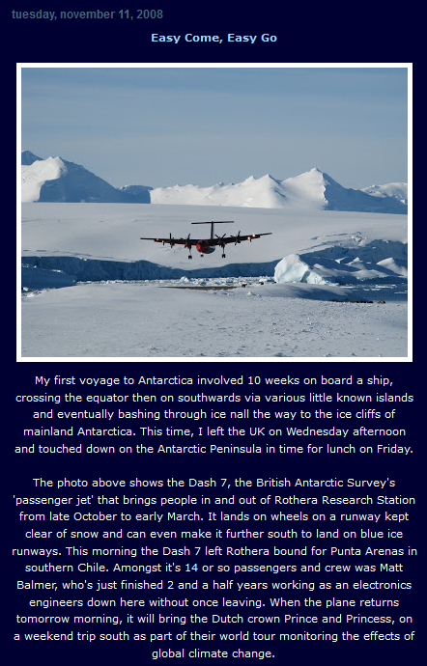
1. Compare the different trips:
 | First trip: | Now:
How did she travel to Antarctica? | She went by … | She went by …
How long was her journey?

2. Let’s talk about the plane on the picture. Cross all the correct statements.
It’s a plane to transport passengers from Chile to the Research Station.
There is an airport next to the Research Station.
The wheels are not made to land on snow and ice.
The pilot is Matt Balmer.
The Research station is the most southern point where you can fly to.
They keep the runways clear of snow so that the plane can land.
There is space for aprox. fourty people on board of this plane.
The plane flies from Punta Arenas to the Research station.
You can use this flight during the summer month.

3. Matt Balmer was working at the Research station as well.
What was his job? ___________________________________________________________________
For how long did he work there without leaving once? _____________________________________

4. The next day, they will be visited by a famous couple. Who is visiting them at the Research Station? And why?
Who? _________________________________________________________________________
Why? _________________________________________________________________________

