Sample test exercises: speaking
A: Look at the pictures and tell what these people normally do. Use present simple. (eher G)
ex: She wakes up at 7 o’clock. He washes his face…..
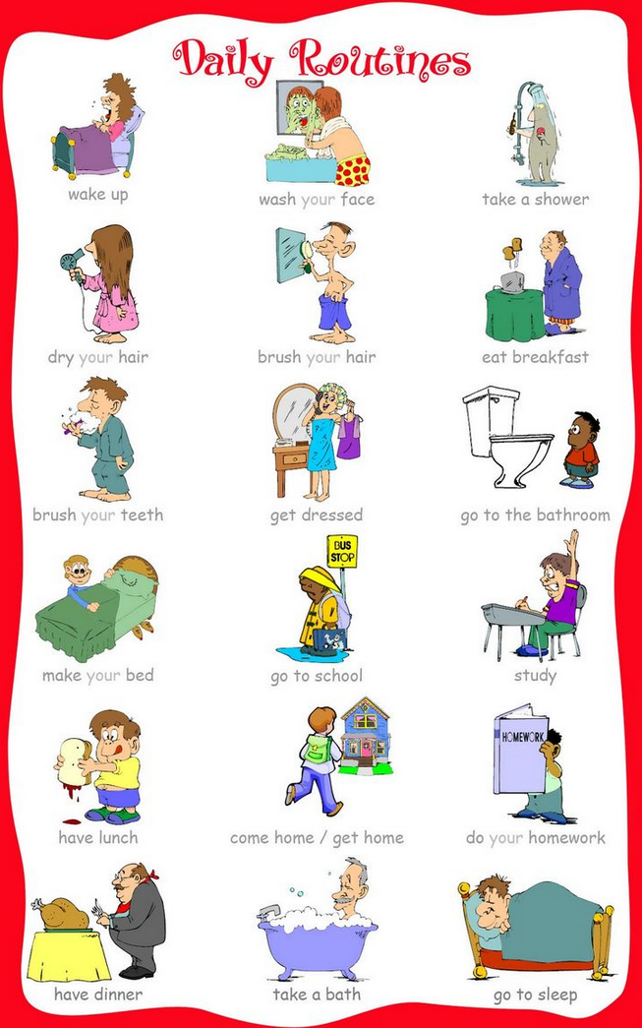
Source: https://s-media-cache-ak0.pinimg.com/736x/e4/71/53/e47153cec3b5f17c779e53373612b3a9.jpg
Evaluation: Does the student speak fluently? Does the students use present simple correctly? Is the pronunciation okay?
B: Look at the pictures and talk about yourself. Use the adverbs of frequency (normally, always, generally, never etc. Link the sentences. (eher für E)
ex: My alarm clock normally rings at 7 o’clock but I always get up at 7.15. Then I always….
Source: https://s-media-cache-ak0.pinimg.com/736x/e4/71/53/e47153cec3b5f17c779e53373612b3a9.jpg
Evaluation: Does the student use present simple correctly? Does the student use the adverbs of frequency? Is the word order correct? Does the student link the sentences together? Does it sound like a whole story or does the student just form one sentence after the other? Does it sound English?
C: Choose a classmate and do this exercise together. Every student must roll the die three times and you have to talk about one topic for at least 1 minute.
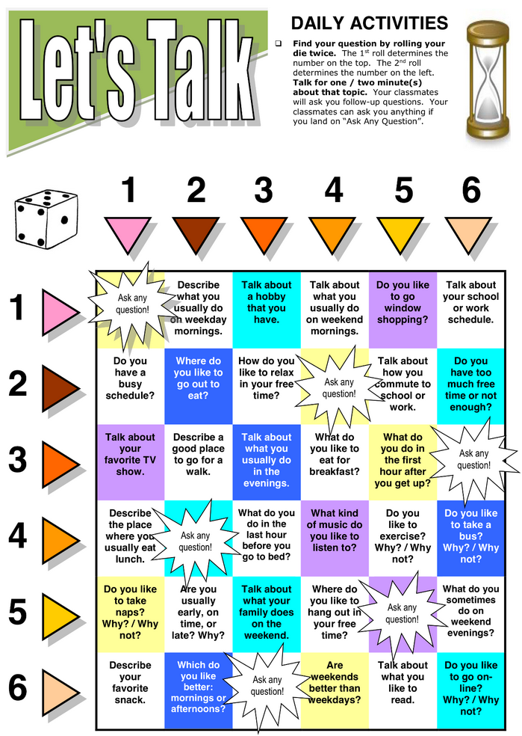
Source: https://s-media-cache-ak0.pinimg.com/originals/37/13/1a/37131a9ad786254bf2636d6a70cfb56f.png
Evaluation: Does the student answer the questions correctly? Does the student ask follow-up questions? Does the Student speak fluently? Does it sound English? Is the word order correct? Does the student use the adverbs of frequency correctly? Is there an interaction between the students?

