Vocabulary training
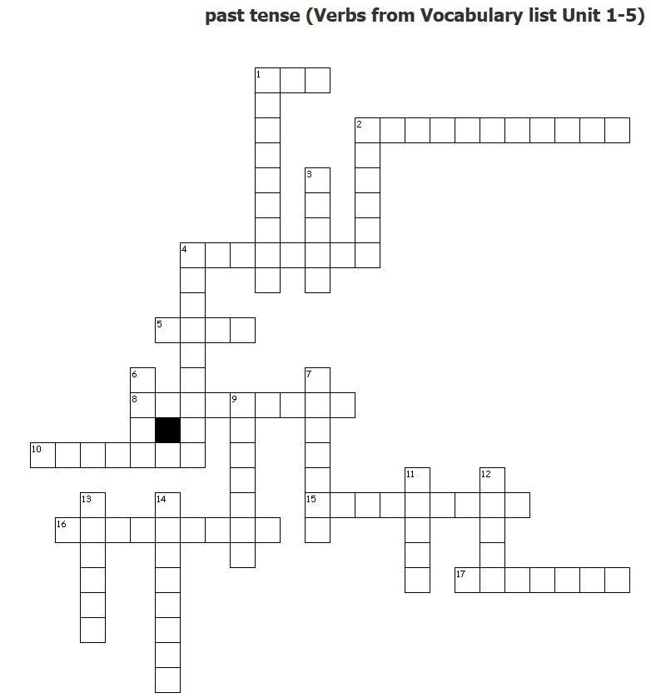
A: Put these words under the right heading. Attention: You don’t need all the words! (Achtung: Nur als Zusatz für sehr gute Schüler. Die meisten Wörter kommen nicht im Voci dieser Unit vor)
explorer, ambitious, bored, catch, hope (n), indigenous, native, port town, present (n), shore, be homesick, dress up, landscape, proud, health, knife, wooden rescue boat, shelter, sleeping bag, useful, boring, melt some ice, hurt.
people | people | survival | survival

B. Fill the gaps with the appropriate word!
unpleasant, desperately, journey, difficulty, introduce, apprenticeship („desperately“ und „apprenticeship“ bei G nicht im Voci, „difficulty“ nicht in dieser Unit im Voci)

Where were you? I was ________________ trying to call you.
May I __________________________ my new friend to you?
The _________________________ to New Zealand takes about 22 hours.
The weather was cold and ______________________________.
Next year, my brother is going to start an ____________________________ as a car mechanic.
They have ________________________ understanding the natives.

Solution:
Where were you? I was desperately trying to call you.
May I introduce my new friend to you?
You should take a cloth and some water and clean your desk.
The journey to New Zealand takes about 22 hours.
The weather was cold and unpleasant.
Next year, my brother is going to start an apprenticeship as a car mechanic.

C: James Cook sees his first… Create your own animal.

This is what I call my animal: _______________________________
It’s about the size of a _________________________, but its shape is different. My animal looks more like a __________________________
It has a ________________________ head with __________ horns and big __________.
It has _________________ legs with _____________________feet and __________________ teeth.
It walks like a _____________________________.
Individual solution:
This is what I call my animal: _________________It’s about the size of a cow, but its shape is different. My animal looks more like a dog. It has a oval head with red horns and big ears. It has eight legs with huge feet and long yellow teeth.It walks like a kangaroo.

D : Create another word out of the word given. (Wörter aus E)
to explore (v) noun: explorer
invention (n) verb: __________________________
to survive (v) noun: __________________________
company (n) verb: __________________________
ambition (n) adjective: __________________________
to be apprenticed (v) noun: __________________________
facial (adj) noun: __________________________
introduction (n) verb: __________________________
order (n) verb : __________________________
psychology (n) adjective : __________________________
to protect (v) noun : __________________________
announcement (n) verb : __________________________
to attempt (v) noun : __________________________
delicacy (n) adjective: __________________________
incredibility (n) adjective : __________________________
pride (n) adjective : __________________________
replacement (n) verb : __________________________

